Money
Spending Wisely  There are lots of things that can influence us when we make decisions about buying items. They include:  -The quality of the item -Its usefulness  -Whether it was fashionable/trendy  -Whether any of our friends have an item like it  -Whether we can afford it  We need to be aware that people sell products to make money. We should think carefully about what we spend money on so we don’t waste our money. | Lending Money  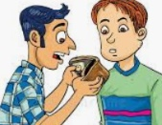  -Lending someone money may seem like a nice thing to do, but it can create an uncomfortable situation. You should consider things like:  -whether the person really needs it; whether they can repay the debt and how close you are to the person.  A loan is a situation where a bank lends someone money. They normally add interest to the loan (an extra charge for lending the money).
Staying Healthy and Safe
Making a Difference  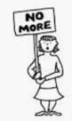  -There are many ways to make a difference to society. E.g. join a voluntary, community, or pressure group. They are all groups that work together to make a bigger difference or change:  -Voluntary group – a group in which the people who take part are not paid in any way.  -Community group – a group that contains representatives who act on behalf of the community.  -Pressure group – a group that tries to influence action or change.  People often join these groups to make society better for everyone. It can also be rewarding for the people who take part, giving them a sense of empowerment and improving their own wellbeing. | Public Services Local Councils  -Public services are those provided by local councils to benefit people in the community and are paid for by taxes. Public services include: education, transport, planning, fire and public safety, social care, libraries, waste management, recycling, housing and trading standards.  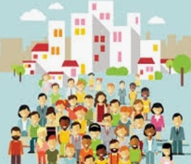  -Local councils are elected by the people in the community. They work together to make decisions about how best to run public services in the area. They debate ideas before voting on what should happen.
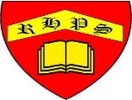
Working together to be the best that we can be
PSHE – Rights and Respect
Year 5
Spring 2
Golden Thread:
Rights and Respect

We are learning about the things that we should have (our rights) and the things that we should do (our responsibilities).
You should already know that: There are some things that we are responsible for, e.g. looking after ourselves, other people and our things.

People and Environments
Rights, Responsibilities and Duties  Right – something people should be allowed to have or are entitled to.  E.g. All children have a right to receive an education.  Responsibility – something that people should do. Being responsible means. means being dependable, making good choices, and taking accountability for your actions.  E.g. I have a responsibility to look after my belongings.  Duties – what we should or must do in order to look after something.  E.g. I clean my bedroom on a weekly basis.  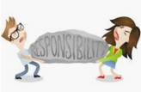  We should consider the effect of duties not being completed. Some duties may be rewarding or enjoyable. | Facts and Opinions  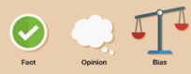  -A fact is something that can be proven to be true (or false), e.g. ‘London is the capital city of the UK.’  An opinion is what somebody thinks about something, e.g. ‘London is the best city in the UK.’  -It is important that we learn the difference between fact and opinion in what we read.  -Sometimes, the way that stories are presented can show bias (they favour one idea over others).  -For example, a news story written about Liverpool being the best football team in the world, written by a Liverpool fan, may show bias!  - We should always try to consider the opposing point of view.

