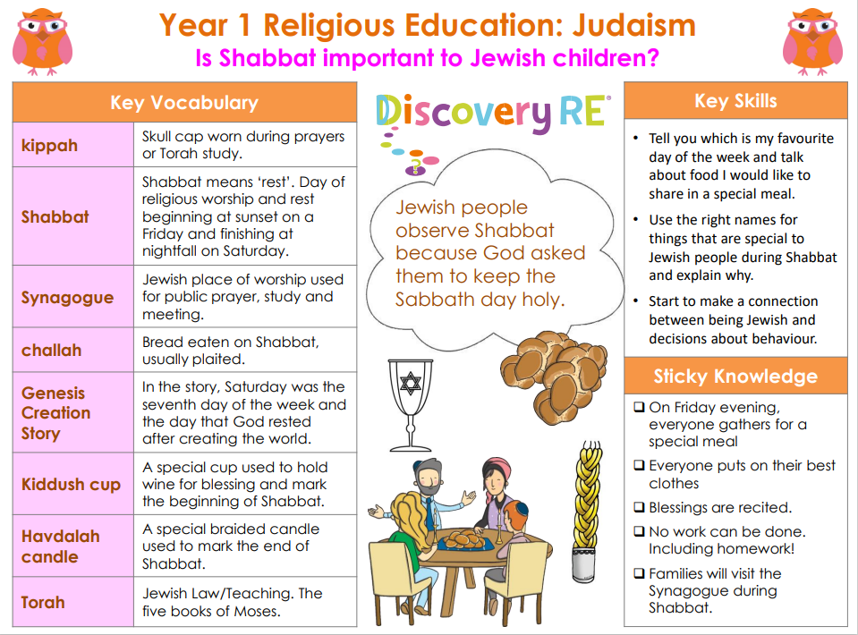

RE – Unit 5 – Judaism: Is Shabbat important to Jewish children?
Working together to be the best that we can be
Golden Thread:

Summer 1
Year 1

