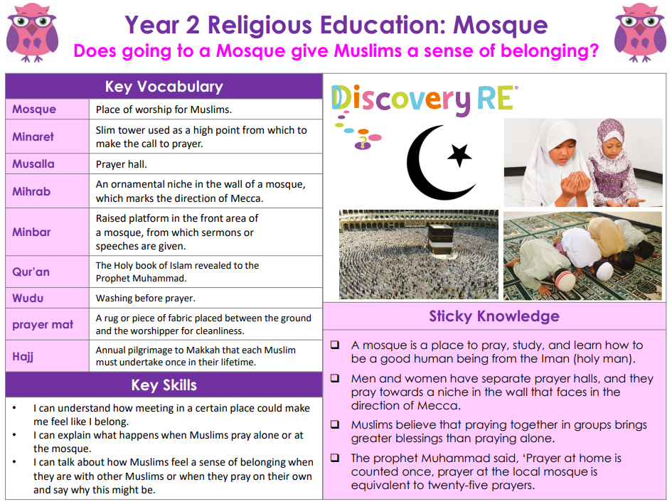

RE – Unit 5 – Islam: Does going to a Mosque give Muslims a sense of belonging?
Working together to be the best that we can be
Golden Thread:

Summer 1
Year 2

