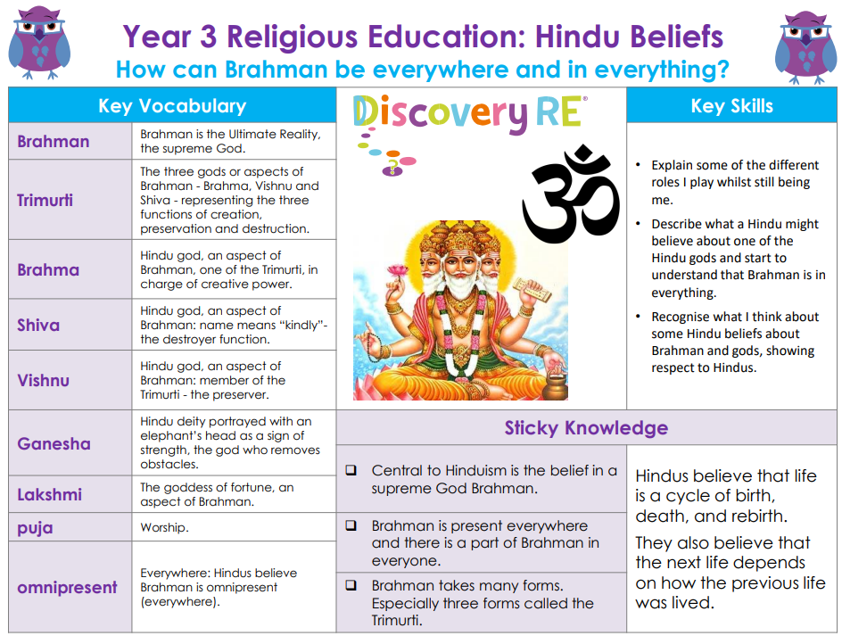

RE – Unit 5 – Hinduism: How can Brahman be everywhere and in everything?
Working together to be the best that we can be
Golden Thread:

Summer 1
Year 3

