
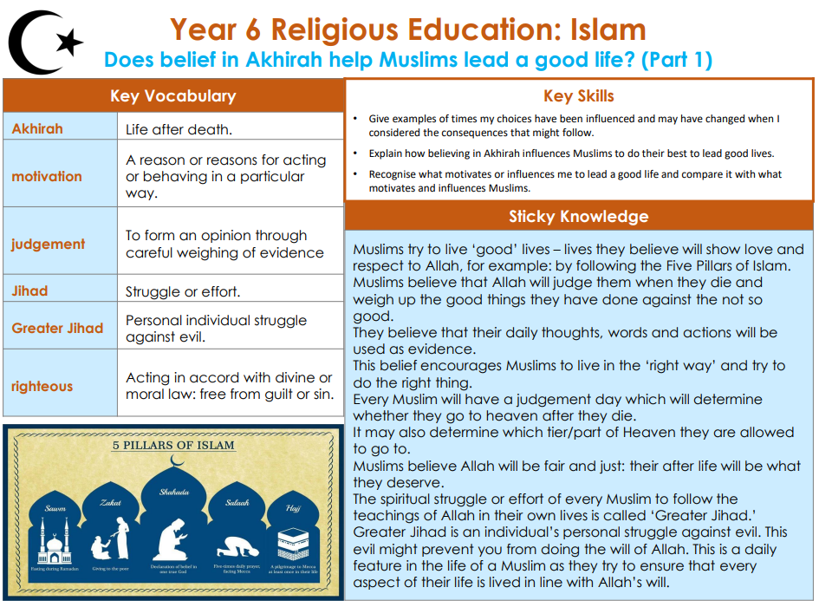

RE – Unit 5 – Islam: Does belief in Akhirah help Muslims lead a good life?
Working together to be the best that we can be
Golden Thread:

Summer 1
Year 6

