
Golden Thread: Belonging
Physical Education – Unit 5 – Cricket
Summer 1
Year 3
Working together to be the best that we can be

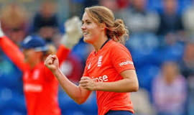
Key Vocabulary:
Batting, fielding, bowling, bat, wicket, stumps, ball, crease, boundary, run, batsman, bowler, wicketkeeper, field, innings.

Stuart Broad Sarah Taylor

New Skills:
Forward drive into space. Bowl with some consistency. Foot placement to strike a ball. Use long barrier to collect a ball. Overarm throw for distance.

