
Golden Thread: Belonging
Physical Education – Unit 5 – Hit, Catch, Run
Summer 1
Year 1
Working together to be the best that we can be

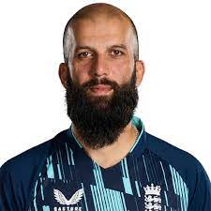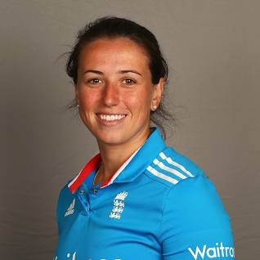
Key Vocabulary:
Batter, bowler, catch, collect, feed, field, hit, hitter, pick up, retrieve, roll, stop, strike, throw.

Moeen Ali Georgie Elwiss

New Skills:
Use a range of throwing and rolling skills. Return the ball back to base/zone. Work with other fielders to stop players scoring. Self-feed ball to hit. Running between bases to score points.

