
Golden Thread: Belonging
Physical Education – Unit 5 – Hit, Catch, Run
Summer 1
Year 2
Working together to be the best that we can be

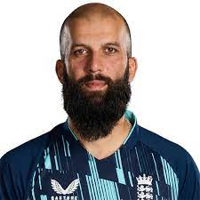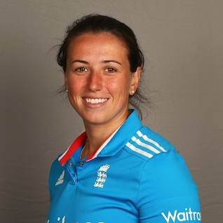
Key Vocabulary:
Hit, catch, runs, wicket, bats, bowl, feed, throw, catch, underarm, overarm, field, hitter, bowler, umpire, posts, stumps.

Moeen Ali Georgie Elwiss

New Skills:
Hitting with bats (some may still hit with hands.) Use kicking to send a ball to score points. Use underarm bowling. Field to catch and throw teammates. Play as part of a team to field and hit to score.

