
Golden Thread: Belonging
Physical Education – Unit 5 – Rounders
Summer 1
Year 4
Working together to be the best that we can be

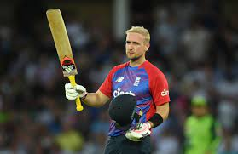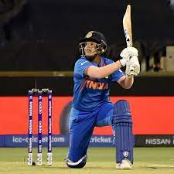
Key Vocabulary:
Batting, fielding, bowling, bat, ball, batsman, bowler, bases, backstop, field, innings, strike, cross, rounder, half-rounder, balls, shot, forward.

New Skills:
Throw and catch with increasing accuracy. Run at speed to avoid being stumped out. Intercept balls to stop runs in game. Play in backstop in a small game situation. Play in a game using rounder’s scoring system.

Liam Livingstone Shafali Verma
*Cricketers, not Rounders players*

