
Golden Thread: Belonging
Physical Education – Unit 5 – Rounders
Summer 1
Year 5
Working together to be the best that we can be

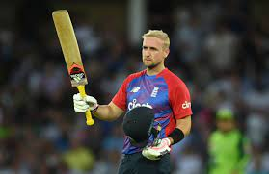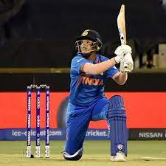
Key Vocabulary:
Stance, bowling, bat, box, batsman, bowler, backstop, field, innings, strike, cross, rounder, half-rounder, over, balls, shot, defensive, offensive.

New Skills:
Apply rules of game consistently. Optimal base positioning. Following the path of the ball. Applying backwards hit rule. Field with some awareness of batters’ strengths.

Liam Livingstone Shafali Verma
*Cricketers, not Rounders players*

