Developing Myself
Learning Lines  Everything that you can do, you had to learn once! E.g. reading, writing, riding a bike, etc.  We can show the learning process on a learning line.  1.Before we learn something new. 2.When it is hard and we want to give up!    3.When we keep going and start to get better at it.  4  1  4.When we have learnt something new.  3  2 | Growth Mindset  Learning can sometimes be difficult, but it is good to challenge ourselves! Encouraging things that we can say to ourselves and others:  -You can do it! -Keep trying -Challenge yourself  -Believe in yourself -Learn from mistakes -You will learn this  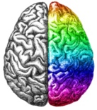  -Learn from others -Let’s try another strategy
Helping Others
Encouragement and Praise    -Our words can have a big impact on other people. We should use our words for good!  -When others are trying new things or are finding things difficult, we should try to encourage (‘you can do it!’) and praise them (‘that was a great effort’) to help them to better themselves. | Positive Behaviours  -Our behaviour is what we do and how we act.  -Our behaviour affects ourselves and also other people.  -We should try to be helpful, kind and considerate.  -Behaving in this way can really help the special people in our lives!
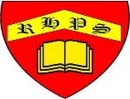
Working together to be the best that we can be
PSHE – Being My Best
Year 1
Summer 1
Golden Thread:
Being My Best

We are learning about how to develop ourselves through learning and challenges, how to be safe and healthy and how to help others.
You should already know that: Learning is how we learn to do new things, and it is not always easy. To be at our best, we should try to live healthily and also help others.

Being Safe and Healthy
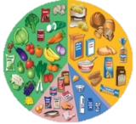  Balanced Diet  Eating a balanced diet is an important part of living a healthy lifestyle. Food and drinks fall into the following groups:  -Fruit and vegetables: They contain vitamins and minerals.  -Carbohydrates: They give us lots of energy!  -Proteins: They help build muscle.  -Dairy: Contain calcium for bones.  -Fats and Sugars: Add fat storage for energy.  Having a balanced diet means not having too much or two little of any one food group. | Catch It, Bin It, Kill It!  -Many illnesses are caused by germs, which can be passed from person to person.  -It is important to catch our coughs and sneezes in tissues and to throw these in the bin.  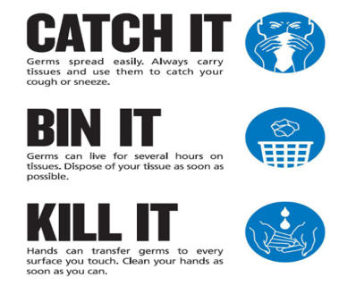  -We should then wash our hands in warm water for at least 20 seconds, to get rid of germs.

