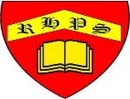
Working together to be the best that we can be
Art – Exploring Watercolour
Summer 1
Year 1
Golden Thread: Social Justice
& Belonging
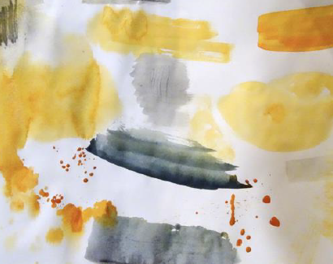
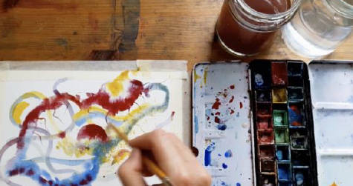
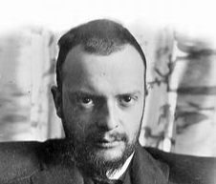
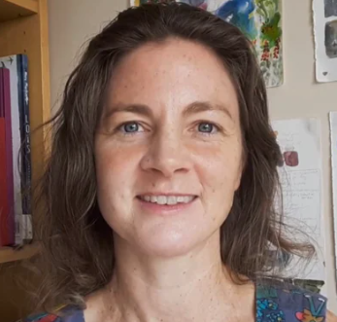
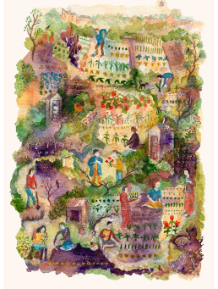
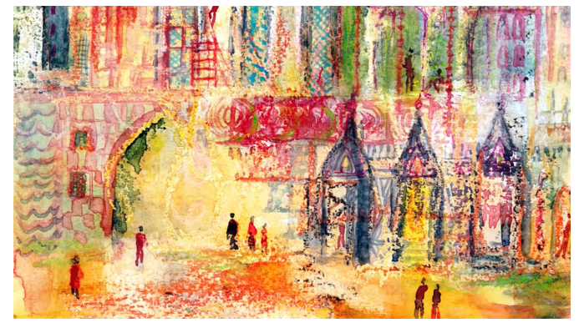
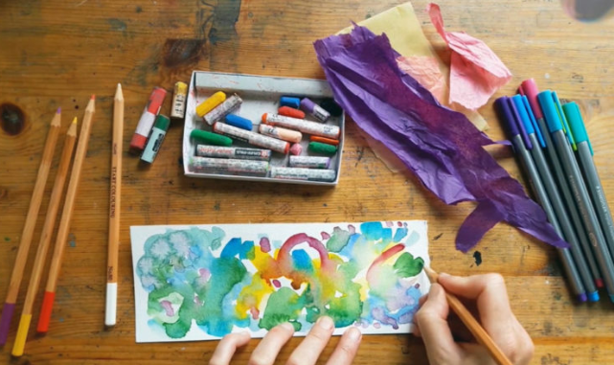
Vocabulary

Watercolour
Wash
Wet on dry
Wet on wet
Mark making
Primary colours
Secondary colours
Colour mixing
Fluid
We will start with an exploration of what watercolour can do.
Temple Gardens (1920) by Paul Klee.
Original from: The MET Museum

Watercolour Paintings

by Emma Burliegh

Artists Emma Burleigh and Paul Klee

Once your watercolour painting is dry, maybe you could develop it further by mixing in other art materials.

