Developing Myself
Learning Lines  Everything that you can do, you had to learn once! E.g. reading, writing, riding a bike, etc.  We can show the learning process on a learning line.  1.Before we learn something new. 2.When it is hard and we want to give up!  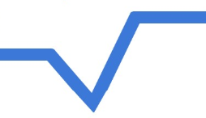  3.When we keep going and start to get better at it.  4  1  4.When we have learnt something new.  2  3 | Making Choices  Throughout our lives we make lots of different choices (e.g. what to have for breakfast, what to spend our day doing etc.)  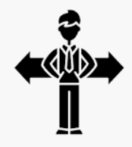  It is important that we learn to think about the choices that we make, and how they affect us ( e.g. the right meals can help to keep us healthy) and others (e.g. being polite to others can help to make them feel happy).
My Body
Our Bodies  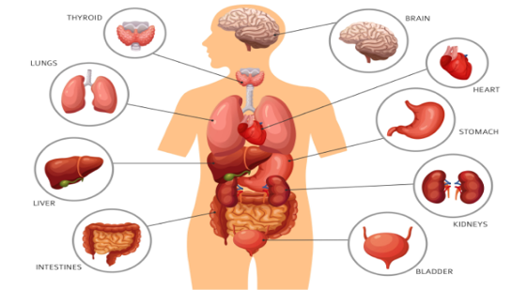  -We should start to think about the different parts inside our bodies, and what their jobs are. | Looking After Teeth  6 top tips for keeping our teeth healthy and strong:  1.Brush twice a day  2. Brush for at least two minutes  3. Just spit afterwards - don't rinse, 4. Avoid sugary food between meals  5. Drink milk;  6. Avoid too many sugary drinks
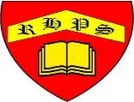
Working together to be the best that we can be
PSHE – Being My Best
Year 2
Summer 1
Golden Thread:
Being My Best
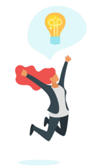
We are learning about how to develop ourselves through learning and challenges, how to be safe and healthy and how to help others.
You should already know that: Learning is how we learn to do new things, and it is not always easy. To be at our best, we should try to live healthily and also help others.

Being Safe and Healthy
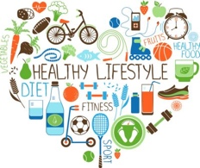  Healthy Lifestyles  Things we can do to live a healthy lifestyle  -Eat healthy meals – We should try to eat a balanced diet.  -Do not eat too much or too little – If we eat too much, we can become overweight. If we eat too little, we may not grow properly.  -Exercise every day – This will help you to have healthy muscles, bones, heart and lungs.  -Be hygienic - Wash hands before eating meals and after going to the toilet, clean your teeth twice a day and wash your body and hair | Exercise  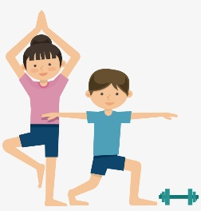  -When we exercise, we help to keep lots of parts of our bodies healthy:  -Our hearts beat faster and our lungs work harder. Over time, this helps them to become stronger.  -We use our muscles – this helps them to grow.  -We burn fat in our bodies. This stops us from getting overweight.  -Remember to stay hydrated (drink water) when you exercise and to allow for periods of rest after exercising.

