
Vocabulary
Music
Rhythm
Gesture
Mark Making
Listen
Respond
Line Weight
Speed
Pressure
Media
Abstract
Line
Shape
Colour
Form
Texture
Balance
Scale
Devise
Invent
Combine
Express
Explore
Construct
Fasten
Wassily Kandinsky was a Russian painter born in 1866. Kandinsky had the gift to be able to associate music with colours.
Working together to be the best that we can be
Art – Collaboration and Community – Music and Art
Summer 1
Year 2
Golden Thread: Material Culture
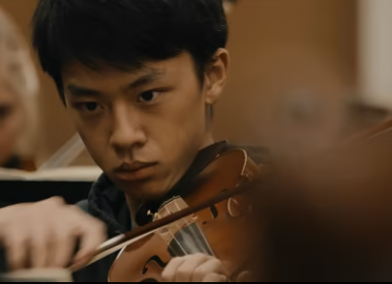

Music and Projection Mapping by Light Odyssey

Projection mapping is a type of digital installation art. Artists project digital film or imagery onto unusual surfaces such as buildings or irregularly shaped objects, creating optical illusions.

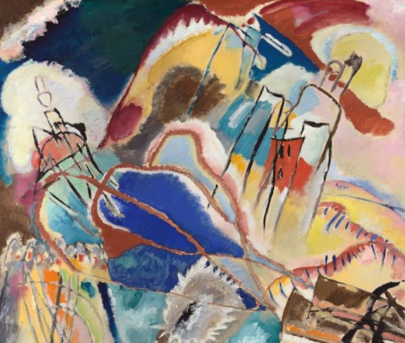

Exploring

Orchestras and Instruments

What kind of music do you think that Kandinsky was listening to when he painted this?

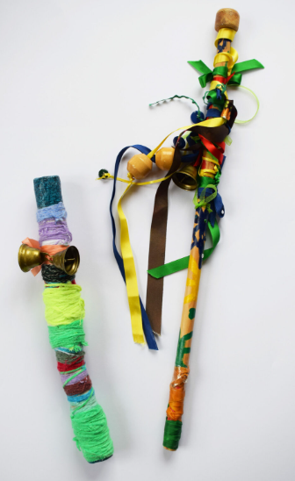


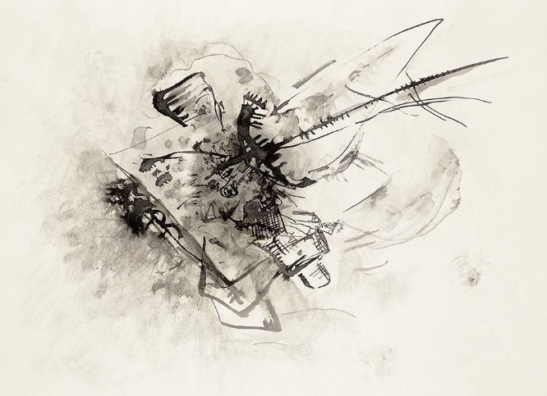
Making Musical
Instruments
How do you think Kandinsky was feeling when he painted this painting?

Untitled (1916) by Wassily Kandinsky. Original from The Art Institute of Chicago.

