Developing Myself
My Talents  -We are all good at different things. Everyone is good at something, even if they feel that they are not!  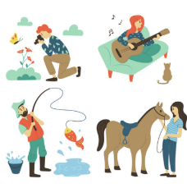  -You should also know some things that you can still improve upon (e.g. ‘using punctuation’ or ‘passing in football.’) You should set some goals and ambitions for the future. Think about how you can work towards them. (e.g. ‘I will learn to play the guitar, by listening to my instructor and practicing for 30 mins each day at home.) | For or Against?    Throughout our lives we have lots of different choices to make about our health and wellbeing (e.g. how we exercise, what we eat, etc.) You should begin to have your own views about a range of health and wellbeing-related topics. Examples may include: ‘For or against – children should only be allowed to eat sweets if they have an adult with them’
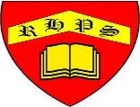
Working together to be the best that we can be
PSHE – Being My Best
Year 3
Summer 1
Golden Thread:
Being My Best

We are learning about how to develop ourselves through learning and challenges, how to be safe and healthy and how to help others.
You should already know that: Learning is how we learn to do new things, and it is not always easy. To be at our best, we should try to live healthily, understand our bodies, and help ourselves and one another.

Being Safe and Healthy
Food Groups  -Fruit and vegetables – These are a great source of vitamins and minerals. Eat lots! About 5 portions per day.  -Carbohydrates – Carbohydrates give us energy for our daily tasks. Include in every meal.  -Proteins – These build and repair body tissues, e.g. muscles, hair, nails. Eat about 2-3 portions per day.  -Dairy – These help to improve our bone health. You should eat about 2-3 portions per day.  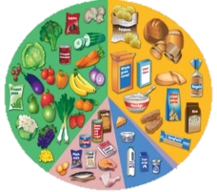  -Fats and Sugars – Too much of these can make us overweight and damage our teeth. | Illness and Medicines  -Even if we live a healthy lifestyle, we all sometimes get ill. Some illnesses may include colds, flu and sickness bugs.  Sometimes, medicines can help to make us feel better. Remember that:  -Medicines should be kept out of reach of children. Make sure an adult looks after the medicine  -Always take the correct dose. If you don’t know this – don’t take it!  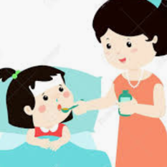  -Only use a medicine when it’s needed. If the illness is only mild, consider an alternative. Often, our bodies can fight off illnesses.
My Body
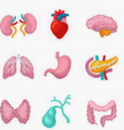  Our Bodies  We should know the different jobs that the major organs in our body have.  1. Heart: pumps blood around the body.  2. Lungs: help pass the oxygen from air into the blood  3. Stomach: breaks down the food and water  4. Small and Large intestine: breaks down the food and water so that it can soak into the blood.  5. Brain: is the control centre of the body. | 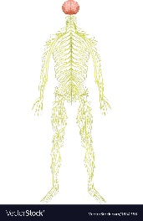  Nerves  -The nervous system controls everything we do, e.g. breathing, walking, thinking & feeling.  -This system is made up of our brain, spinal cord, and all the nerves of your body. The brain is the control center and the spinal cord is the major highway. Our brains send messages to/ from the nerves.

