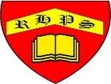
Working together to be the best that we can be
Art – Collaboration and Community – Using Natural Materials To Make Images
Summer 1
Year 3
Golden Thread: Social Justice & Belonging
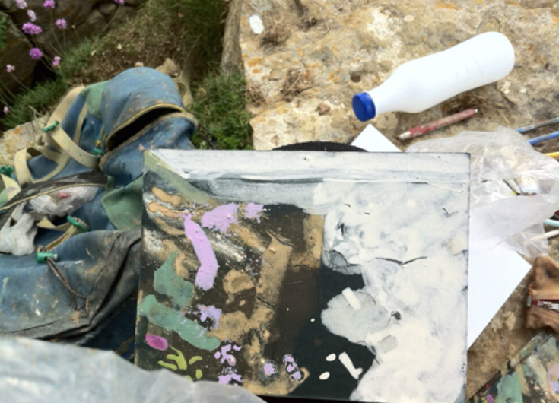

Francis Hatch

Francis is a plein-air artist who responds creatively to the landscape around her. Francis uses the natural materials available to her in the environment that she is painting in, for example soil and grass or rock pigment.

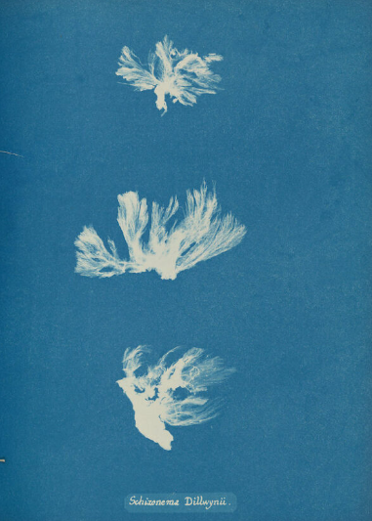

Schizonema Dillwynii by Anna Atkins,

Gilman Collection, Purchase, The Horace W. Goldsmith Foundation Gift, through Joyce and Robert Menschel, 2005

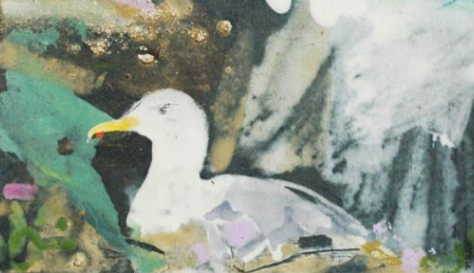
Finished artwork inspired by the Guillemot egg. “I used the quality of the lines and the colour throughout my residency at Durlston” -Francis Hatch.
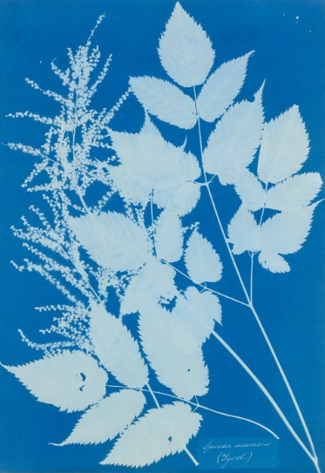

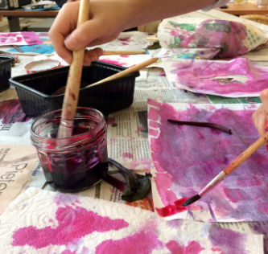

Spiraea aruncus (Tyrol) by Anna Atkins, Purchase, Alfred Stieglitz Society Gifts, 2004

Vocabulary
Negative Positive
Light
Dark, Elements Pattern
Form
Transformation
Time
Cyanotype Anthotype

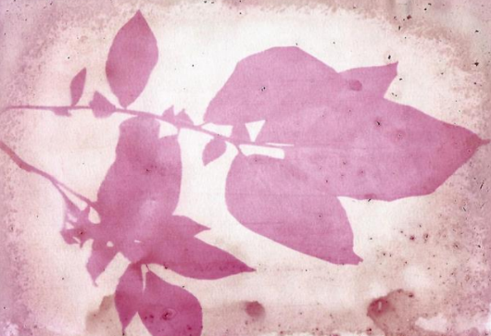
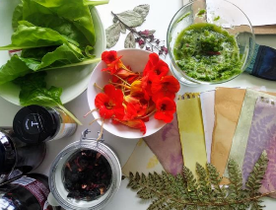
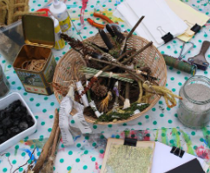
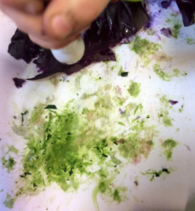

Anna Atkins

Anna Atkins was a botanist and photographer in the 1800s. She is considered as the first person to publish a book of photographs. The process she used was called cyanotype.

Guillemot blue colour, a fragment of egg and cliff material with gouache on off cuts of mount board.

