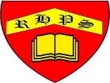
Golden Thread: Sustainability
Geography – Unit 3 – Water and weather
Summer 1
Year 3
Working together to be the best that we can be
Water can be a solid, a liquid or a gas. It changes between solid, liquid and gas many times in nature. Mostly, we see water as a liquid. However, whether water is a solid, a liquid or a gas depends on its temperature (how warm or cold it is):
• When water becomes very cold (below 0°C), it freezes and forms ice. Ice is a solid.
• When water gets very hot, it evaporates and forms water vapour. Water vapour is a gas.
• When water vapour cools down, it turns back into a liquid. This is called condensation.

Talking Points
Where is Earth’s water?
Why does it rain?
Why do we have seasons?
What is the weather forecast?

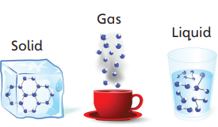

Key vocabulary
Air masses - huge areas of air that have the same temperature and the same amount of water vapour.
Condensation - when a gas turns into a liquid.
Evaporation - when a liquid turns into a gas.
Forecast - a prediction about what will happen in the future, based on evidence.
Gravity - an invisible force that pulls things towards the centre of the Earth.
Hemisphere - half of the Earth: the top half is the northern hemisphere, the bottom half the southern hemisphere.
Rain shadow - the side of a mountain that does not get much rain.
Solar system - the Sun and everything that travels round it.
Water cycle - how water moves around the Earth, evaporating and condensing.
Water vapour - water that is in the form of a gas.


