Developing Myself
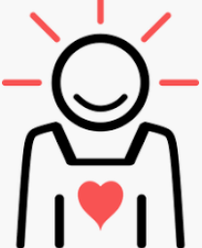  Amazing Me  -We are all good at different things. Everyone is good at something, even if they feel that they are not! This is good, as it means that different people can help us at different things.  -You should also know some things that you can still improve upon.  -You should be aware that different people have different talents, strengths, weaknesses, likes and dislikes to you. It is important that we negotiate and compromise with those around us. | Community  -A community is a group of people who live in the same place or have a particular thing in common.  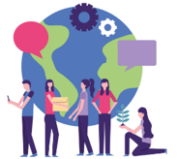  -We belong to many different communities, e.g. our school community, our local community, or different clubs etc. that we are part of.  -Studies have shown that people who have a strong sense of belonging to a community can be happier and even healthier than those who don’t. It is important for us to feel connected to others in life, and so we should work hard to maintain our communities.
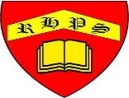
Working together to be the best that we can be
PSHE – Being My Best
Year 4
Summer 1
Golden Thread:
Being My Best
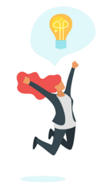
We are learning about how to develop ourselves through learning and challenges, how to be safe and healthy and how to help others.
You should already know that: Learning is how we learn to do new things, and it is not always easy. To be at our best, we should try to live healthily, understand our bodies, and help ourselves and one another.

Being Safe and Healthy
Food Groups  -Fruit and vegetables – These are a great source of vitamins and minerals. Eat lots! About 5 portions per day.  -Carbohydrates – Carbohydrates give us energy for our daily tasks. Include in every meal.  -Proteins – These build and repair body tissues, e.g. muscles, hair, nails. Eat about 2-3 portions per day.  -Dairy – These help to improve our bone health. You should eat about 2-3 portions per day.  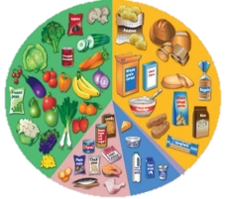  -Fats and Sugars – Too much of these can make us overweight and damage our teeth. | First Aid    This is the help and care that we can give to someone who is sick or injured, before full medical help arrives.  -We should learn to spot dangers, so that there is less chance of accidents happening. When we see that someone is badly hurt or sick, we should call 999 for the emergency services.
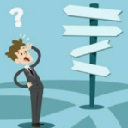
Choices
-A choice is when we have to pick from more than one option.
We should be beginning to make the right choices in relation to our health and wellbeing.
My Body
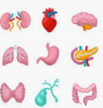  Our Bodies  We should know the different jobs that the major organs in our body have.  1. Heart: pumps blood around the body.  2. Lungs: help pass the oxygen from air into the blood  3. Stomach: breaks down the food and water  4. Small and Large intestine: breaks down the food and water so that it can soak into the blood.  5. Brain: is the control centre of the body. | 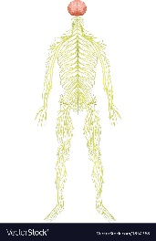  Nerves  -The nervous system controls everything we do, e.g. breathing, walking, thinking & feeling.  -This system is made up of our brain, spinal cord, and all the nerves of your body. The brain is the control center and the spinal cord is the major highway. Our brains send messages to/ from the nerves.

