
Working together to be the best that we can be
Art – Print, Collage, Colour – Exploring Pattern
Year 4
Golden Thread: Civilisations & Belonging
Summer 1
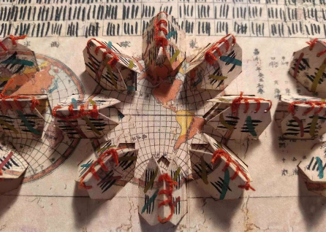
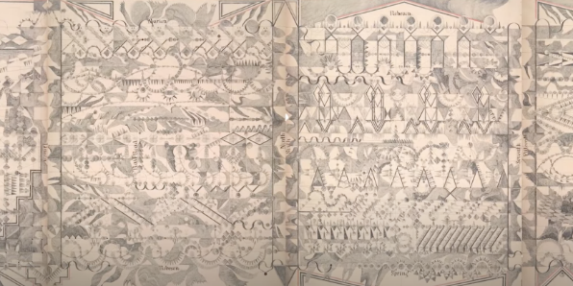

Shaheen Ahmed

“When countries are at war, when people are suffering, that is the time to reach out. The very least we should do is empathise.”

The concept of empathy is central to Shaheen’s work.

Vocabulary
Pattern
Sensory
Playful
Mindful
Point
Line
Shapes
Circles
Ovals
Curves
Decorative
Aesthetic
Tessellated
Design
Colour
Pattern
Repeating
Composition
Juxtaposition
Collage
Fold
Origami
Design

Lousie Despont

Louise Despont is an artist whose practice focuses on drawing. Her works comprise of detailed geometric drawings which evolve organically.

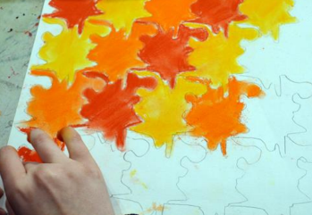
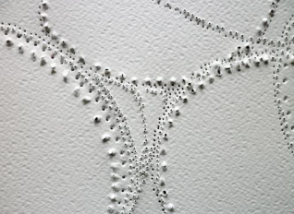

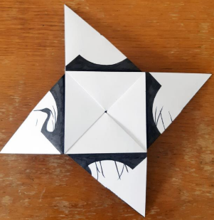
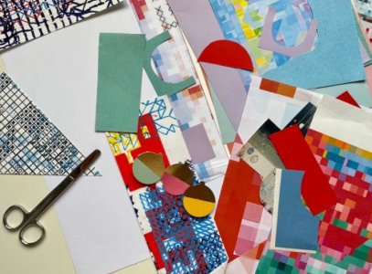
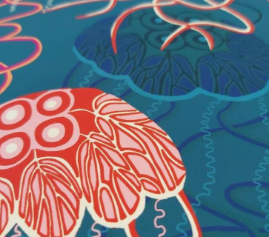
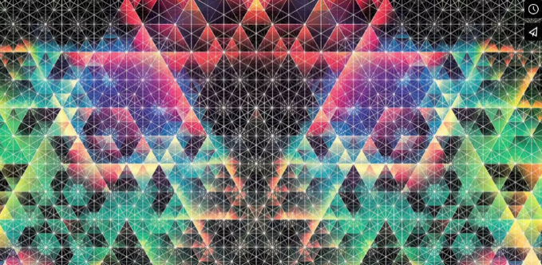
The act of making drawings can be mindful.
We can use line, shape and colour to create patterns.
We can use folding, cutting and collage to help us create pattern.
We can create repeated patterns to apply to a range of products or outcomes.

Andy Gilmore

A master of colour and geometric composition, Andy Gilmore’s work is often characterised as kaleidoscopic and hypnotic, though it could just as well be described as visually acoustic, his often complex arrangements referencing the scales and melodies in music.

