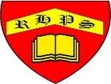
Golden Thread: Sustainability
Geography – Unit 3 – Natural resources
Summer 1
Year 4
Working together to be the best that we can be
Talking Points
What are the world’s natural resources?
How has the use of natural resources changed?
How can using natural resources cause problems?
Natural resources are materials used by humans that are formed naturally.

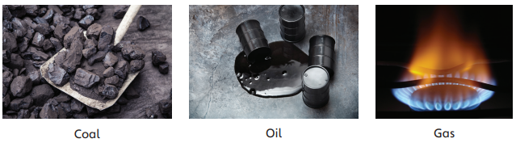
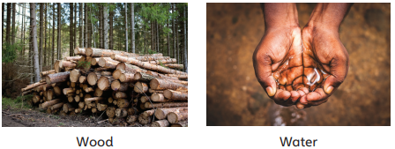

Renewable resources
Some natural resources, such as air and water, will always be available: they will never run out. These are called renewable resources. Wood is a renewable resource too, as it can be reproduced within one person’s lifetime.
Key vocabulary
Clean energy - energy processed in a way that does not cause pollution or release much carbon dioxide.
Climate - general or average weather conditions over a very long period of time.
Exports - products that a country produces and sells to other countries.
Fossil fuels - coal, oil and gas: fuels that are formed from the remains of plants and animals changed by millions of years of heat and pressure.
Mining - digging up natural resources so they can be used.
Natural resources - materials used by humans that are formed naturally.
Non-renewable Able to run out; not able to be reproduced effectively.
Pollution - harmful substances released into the environment.
Renewable - Not able to run out; always available.
Reserves - Quantities of a substance not yet used.
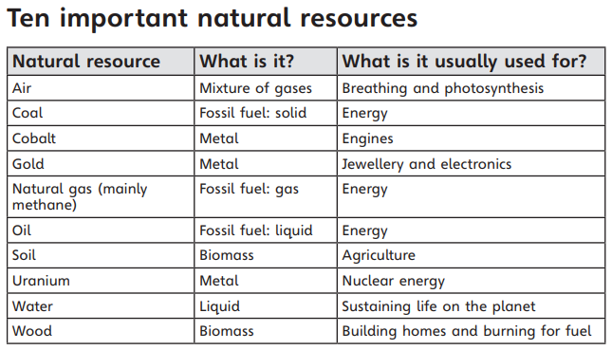

Non-renewable resources
Other natural resources are non-renewable, which means there is only a limited quantity of them. They will run out if people keep using them. Coal, oil and gold are all non-renewable resources.

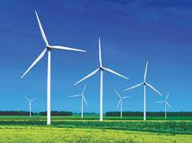
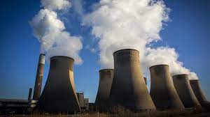
Clean energy
To help our environment, people are choosing to use more renewable energy supplies like wind energy. This energy does pollute our air.
Fossil fuels
Burning fossil fuels, like coal, causes air pollution because it releases little particles into the air. Sometimes, this can be seen as smoke.
Countries rich in natural resources
- Australia
- Democratic Republic of the Congo
- Saudi Arabia

