Developing Myself
Star Qualities  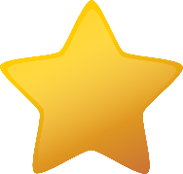  -The things that we see in the media are not always true to life!  Often, images of the people that we see on social media, adverts, magazines etc. have been edited and photoshopped in different ways. We should focus less on people’s physical qualities and more on their star personal qualities, such as:  Generous Considerate Kind  Intelligent Indiscriminate Resilient | 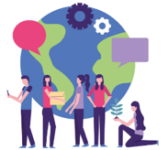  Community  -A community is a group of people who live in the same place or have a particular thing in common.  -We belong to many different communities, e.g. our school community, our local community, or different clubs etc. that we are part of.  -Studies have shown that people who have a strong sense of belonging to a community can be happier and even healthier than those who don’t. It is important for us to feel connected to others in life, and so we should work hard to maintain our communities. In order to develop our communities, we should have an active voice in improving them, e.g. partaking in school councils.
  Independence and Responsibility  Independence is about being able to do things for yourself. For example, you can show independence when you complete your homework without being asked to!  Responsibility is about being dependable, making good choices, and being accountable for your actions. For example, you may be given the responsibility of being a prefect for younger children in your school. | Different Skills  Skills can be developed – they are not fixed. Everyone who is very skilled at something had to start somewhere.  -You should be aware of the things that you are skilled at. Think – how did you get better at it?  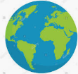  -You should also know some things that you can still improve upon.  -You should be able to set yourself clear and manageable targets in order to reach your goals.
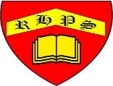
Working together to be the best that we can be
PSHE – Being My Best
Year 5
Summer 1
Golden Thread:
Being My Best
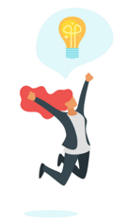
We are learning about how to develop ourselves through learning and challenges, how to be safe and healthy and how to help others.
You should already know that: Learning is how we learn to do new things, and it is not always easy. To be at our best, we should try to live healthily, understand our bodies, and help ourselves and one another.

Being Safe and Healthy
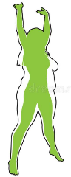  Getting Fit  -A healthy, balanced diet – This should include lots of fruit and vegetables (for vitamins and minerals), proteins (for muscle repair and growth) and carbohydrates (for energy). Diets should not include too many sugars or fats.  -Regular Exercise – Including aerobic training (e.g. running, cycling) to strengthen the heart and lungs.  -Sleep – About 10-11 hours for primary-aged children. About 8 hours for adults.  -Fresh Air and Water – Fresh air helps to keep our lungs and blood cells healthy. Water helps to keep our bodies hydrated  -Good Hygiene and Habits – It is important that we keep our bodies, hair and teeth clean. | Our Amazing Bodies  -Our bodies have over 200 bones and over 600 muscles.  -Our bones protect our organs, support our body, create blood cells, and store vitamins and minerals.  -Our muscles enable us to move.  -Our organs (e.g. heart, brain, lungs) serve a number of important purposes.

First Aid
This is the help and care that we can give to someone who is sick or injured, before full medical help arrives.
-We should learn to spot dangers. When we see that someone is badly hurt or sick, we should call 999 for the emergency services.

