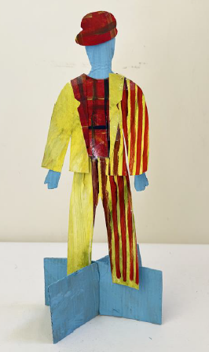


Fashion Designers and Artists

Alice Fox

Alice Fox is a Fashion Graduate from Norwich University of the Arts. Her final year collection is inspired by 1960 seaside resorts. Alice’s garments are influenced by old family photos, deckchairs and fairground rides.

Rahul Mishra

Rahul Mishra runs a sustainable couture brand that works with handmade techniques to empower the craftsmen in New Delhi. Rahul Mishra is the first Indian designer to showcase at the Paris Haute Couture Week.

Pyer Moss

Pyer Moss (pronounced ‘Pierre’) founder Kerby Jean-Raymond grew up in Brooklyn, the son of Haitian immigrants, and has been engaging with the fashion industry since his teenage years. Now in his 30s, Jean-Raymond has been at the helm of Pyer Moss since 2013, naming it for his mother.

Tatyana Antoun

Tatyana Antoun is a fashion designer from Beirut, Lebanon. Tatyana’s collection ‘Vamata’ explores the social restrictions in Lebanon. Her work is heavily influenced by 80’s power dressing and the Club Kids of New York during the 90’s.

Working together to be the best that we can be
Art – Collaboration and Community – Fashion Design
Summer 1
Year 5
Golden Thread: Material Culture & Social Justice
Designers bring their own culture, experiences and passions into their designs, for other people.
Contemporary
Historical
Fashion Design
Designers
Design Brief
Colour
Texture
Shape
Form
Texture
Material
Body
Wearable
Fit for Purpose
2d
3d

