
Golden Thread: Sustainability
Geography – Unit 3 – Energy and sustainability
Summer 1
Year 5
Working together to be the best that we can be
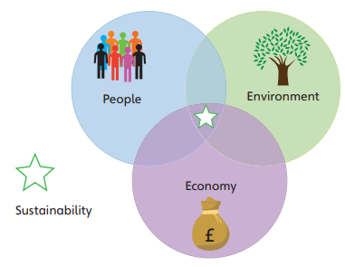
Talking Points
What is sustainability?
Are fossil fuels sustainable?
What are renewable sources of energy?
How can we help our environment?
Sustainability: being able to support people, the economy, and the environment equally.
Humans rely on the environment for the air we breathe, the food we grow and eat, the water we drink and the places we live.
The environment is under pressure from population growth, poverty, development, and climate change.
Investing in renewable energy can be very costly. Not all countries can afford to change to these more sustainable options.

Key vocabulary
Economic/economy - relating to how money and resources are used in a society.
Fossil fuels - coal, oil, and gas etc – fuels that take millions of years to form.
Non-renewable energy - energy sources that will run out, such as fossil fuels and nuclear energy.
Renewable energy - energy sources that are replaced naturally and do not run out, such as solar and wind energy.
Sustainable - when something is good for people, the environment, and the economy.
Technology - tools and techniques that help solve problems.
Unsustainable - when something is not good for people, the environment and the economy.

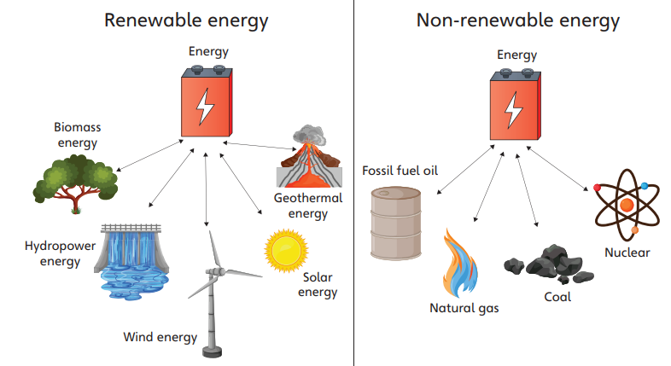
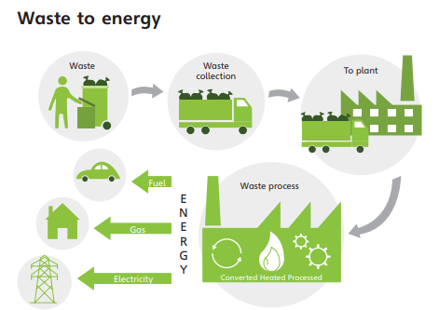

What small things can you do to promote a more sustainable future?
Example:
Non-renewable are sources of energy that will run out. Once they have been used up, there will be none left, as humans have used them quicker than the rate they form.
Renewable energy are sources of energy that will not run out. They keep on being generated by the planet because they are part of the planet’s natural processes.
