Developing Myself
  Star Qualities  -The things that we see in the media are not always true to life!  Often, images of the people that we see on social media, adverts, magazines etc. have been edited and photoshopped in different ways. We should focus less on people’s physical qualities and more on their star personal qualities, such as:  Generous Considerate Kind  Intelligent Indiscriminate Resilient | 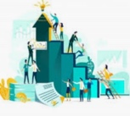  Aspirations  -An aspiration is a hope or ambition of achieving something.  -Your aspirations may relate to your education, occupation (job), where you want to live, money, relationships, career and many other aspects of life.  -Remember that most skills that most skills come from resilience and perseverance - a person working hard at something, from practicing it over and over again.  -You should begin to identify some long-term aspirations of your own. You should also consider what early steps you may need to take now (and steps later in the future) in order to be successful.
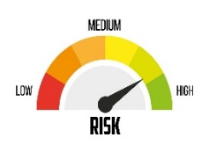
Managing Risks
Risk – an action which is taken in a hazardous situation
Dilemma – when we need to make a difficult choice.
Often, when we have a dilemma, it is important to weigh up the risks. We should be able to determine actions that are high risk, medium risk or low risk. To manage the risk, we should consider:
- What is the situation? 2. What is the risk level? 3. How can I make the situation safer?
4. Which choice is the safest? 5. What is the risk level now?
-We should remember that not all risks are bad – we can often get the best out of ourselves when we are prepared to take measured risks. (e.g. performing in front of lots of people, and doing well!)
-There are several things that we can do to inform our decisions, for example getting some more information or asking a trusted adult. We all have to deal with chance events in our life and need to manage those in a way which helps us and keeps us safe.
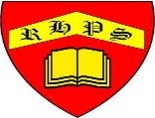
Working together to be the best that we can be
PSHE – Being My Best
Year 5
Summer 1
Golden Thread:
Being My Best

We are learning about how to develop ourselves through learning and challenges, how to be safe and healthy and how to help others.
You should already know that: Learning is how we learn to do new things, and it is not always easy. To be at our best, we should try to live healthily, understand our bodies, and help ourselves and one another.

Being Safe and Healthy
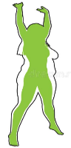  Improving and Maintaining fitness  -A healthy, balanced diet – This should include lots of fruit and vegetables (for vitamins and minerals), proteins (for muscle repair and growth) and carbohydrates (for energy). Diets should not include too many sugars or fats.  -Regular Exercise – Including aerobic training (e.g. running, cycling) to strengthen the heart and lungs.  -Sleep – About 10-11 hours for primary-aged children. About 8 hours for adults.  -Fresh Air and Water – Fresh air helps to keep our lungs and blood cells healthy. Water helps to keep our bodies hydrated  -Good Hygiene and Habits – It is important that we keep our bodies, hair and teeth clean. | Five Ways to Wellbeing  -The New Economic Foundation suggest that there are five ways that we can improve wellbeing.  1. Connect  2. Be Active  3. Take Notice  4. Keep Learning  5. Give  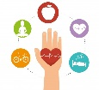  -We should be able to brainstorm practical ideas for each of the 5 ways.

First Aid
This is the help and care that we can give to someone who is sick or injured, before full medical help arrives.
-We should learn to spot dangers. When we see that someone is badly hurt or sick, we should call 999 for the emergency services.

