
Golden Thread: Material Culture & Civilisations
Working together to be the best that we can be
Art – Making, Drawing, Sketchbooks – Shadow Puppets
Summer 1

Year 6
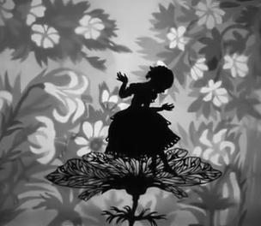

Lotte Reiniger was a German animation pioneer in the early 20th Century. Reiniger’s work focused on silhouette animation, she made over 40 films throughout her lifetime.

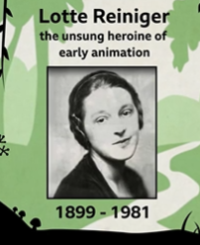
Artists and craftspeople adapt the traditions they inherit to make them their own, and to reflect the culture they live in.

Thumbelina by Lotte Reiniger

paper cutting
cut outs
shadow puppets
performance
narrative
character
present
share
reflect
articulate
feedback
similarities differences

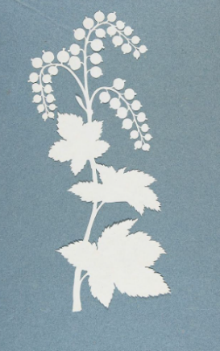
Paper cut out artists:

Phillipp Otto Runge (left)

Pippa Dyrlaga (right)

Thomas Witte (below)

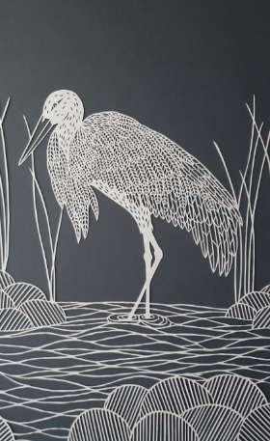
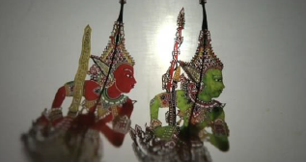

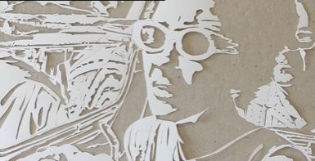

There are many traditions of using intricate cut outs as shadow puppets to narrate archetypal stories.

Malaysian Shadow Puppets

Puppet masters in Malaysia are modernising the 250 year old tradition of Wayang Kulit (a traditional form of puppet-shadow play).

