
Golden Thread: Belonging
Physical Education – Unit 6 – Athletics
Summer 2
Year 3
Working together to be the best that we can be

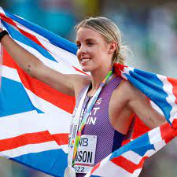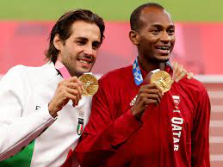
Key Vocabulary:
Run, jump, throw, agility, power, speed, track, force, distance, curve, accelerate, hurdles, foam javelins, vortex howler, bounce, pull, record, pace, approach, combine.

Keely Hodgkinson Barshim and Tamberi

New Skills:
Jumping and hopping sequences. Running at different speeds. Approach and jump hurdles. Throw a javelin using the push-throw technique. Skipping techniques. Keeping score accurately over a range of events.

