
Golden Thread: Belonging
Physical Education – Unit 6 – Athletics
Summer 2
Year 4
Working together to be the best that we can be

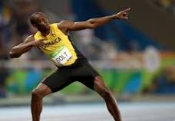
Key Vocabulary:
Run, jump, throw, agility, power, speed, track, force, distance, curve, accelerate, hurdles, foam javelins, vortex howler, bounce, target, take off, sling, exchange, accuracy.

Usain Bolt Jasmine Sawyers

New Skills:
Challenge ourselves in running, jumping and throwing. Accelerate over short distances. Run and jump using one-footed take-off. Use a sling action to throw a discus. Run on a curve and exchange a baton in our team. Apply the skills we have developed in a competitive way.

