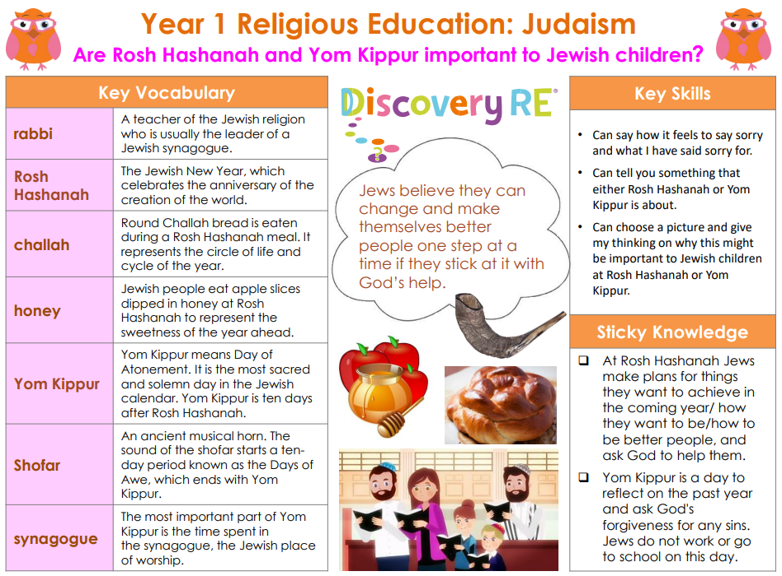
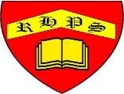
RE – Unit 6 – Judaism: Are Rosh Hashanah and Yom Kippur important to Jewish children?
Working together to be the best that we can be
Golden Thread: Belonging

Summer 2
Year 1

