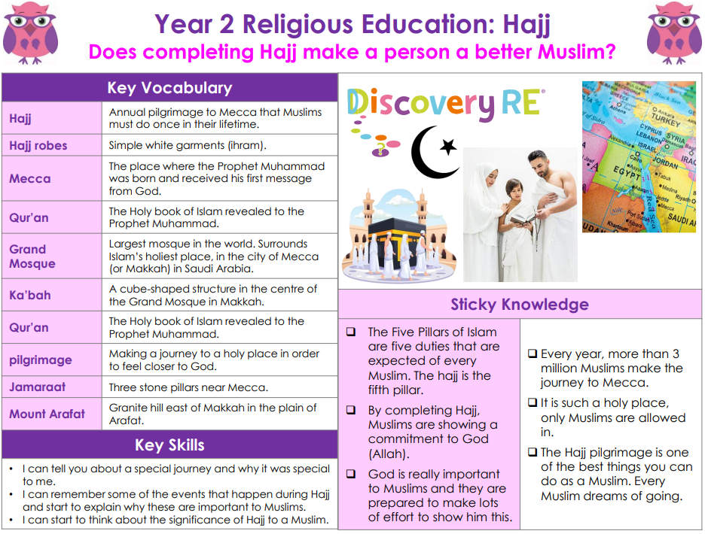

RE – Unit 2 – Islam: Does completing Hajj make a person a better Muslim?
Working together to be the best that we can be
Golden Thread: Belonging

Summer 2
Year 2

