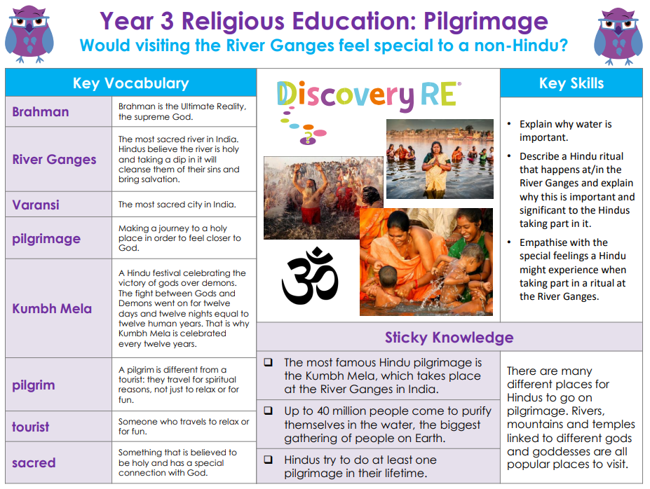

RE – Unit 6 – Hinduism: Would visiting the River Ganges feel special to a non-Hindu?
Working together to be the best that we can be
Golden Thread: Belonging

Summer 2
Year 3

