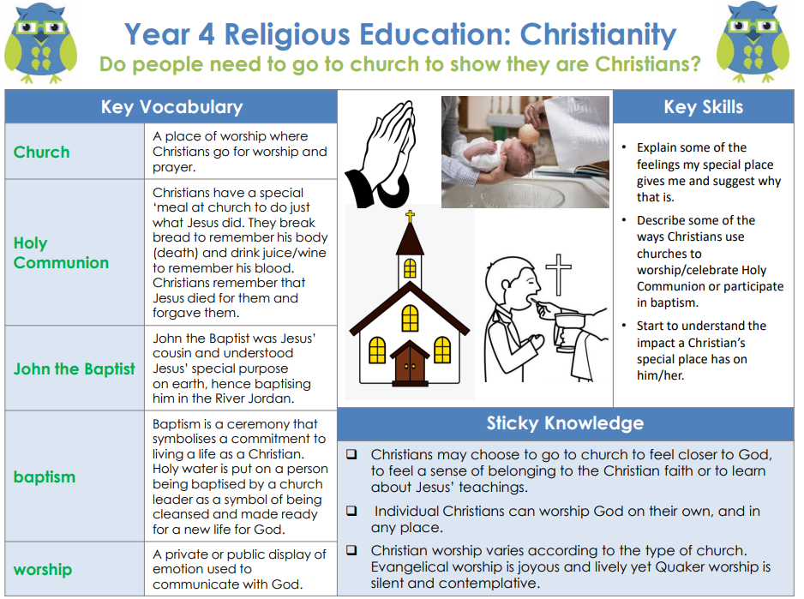

RE – Unit 6 – Christianity: Do people need to go to church to show they are Christians?

Working together to be the best that we can be
Golden Thread: belonging

Summer2
Year 4

