Healthy Relationships
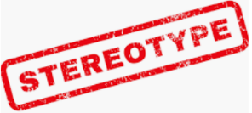  Stereotypes  -A stereotype is an often unfair and untrue belief that many people have about all people or things with a particular characteristic.  -For example, some people may stereotype that girls wear pink or that boys shouldn’t cry.  -Stereotypes are not based on fact: they are based on assumptions & prejudice (pre-judging people). Therefore, stereotypes can be dangerous.  -There are often stereotypes around sex, gender and sexual orientation. People who are seen to be different can sometimes be bullied. Remember:  -Being gay Is perfectly fine and normal;  -It is fine for boys to cook, sew, design etc. and it is fine for girls to have short hair, play football etc. |   Embarrassment  -During puberty, young people often become more aware of what the people around them think.  -The thoughts of their peers can become particularly important to us at this time.  -This can mean that there are more times where we may feel embarrassed about things that didn’t used to bother us as much. Some examples may include:  Falling over Not knowing an answer in class  Someone calling teacher ‘mum’ Sitting alone  -How other people react to us in times of embarrassment can really help us to feel more comfortable. Some things that they can do include talking to them or letting a trusted adult know.  -However, remember that it may be overwhelming for too many people to help someone at the same time.

Secrets and Surprises
-A surprise is when something happens that someone wasn’t expecting. A secret is when someone tells us not to tell something. Secrets can sometimes be bad. We don’t have to keep secrets if they make us feel uncomfortable.
We may feel uncomfortable ‘breaking confidence’ with someone, but it is the right thing to do when it is unsafe.
There are lots of different people who we can turn to when we feel uncomfortable.

Working together to be the best that we can be
PSHE – Growing and Changing
Year 5
Summer 1
Golden Thread:
Growing and Changing
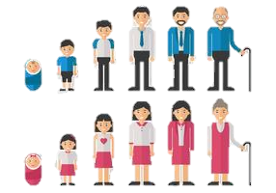
We are learning about our bodies and our relationships with ourselves and others. We are focusing on how these things grow and change over time.
You should already know that: Our bodies have many different parts that have different jobs. Throughout puberty, our bodies go through several different changes. We also go through emotional changes.

Knowing our Bodies
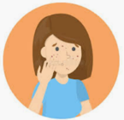  Is this Normal?  As we grow up, our bodies change and develop. This change can be quite unsettling at the time, so it is important that we know what to expect.  - Puberty is the series of changes that our bodies make as we turn from boys and girls into men and women  - Puberty starts between ages 8 and 13 in girls and ages 9 and 15 in boys. At this age, young people will become aware of changes that are taking place to their bodies.  There is lots of information available to us, but it is important to know what is true and what is false.  Some key terms that relate to puberty are:  Acne Body Odour Period  Breasts Penis Vagina Hormones | 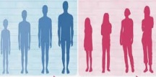  Puberty and Feelings  Puberty starts when hormones are triggered by the brain. Hormones also affect our mood and our feelings. This can make a young person think and feel different. They may want to be more independent and think about adulthood.  -Young people should learn what their different feelings are, e.g. anxiety, anger, disappointment.  -They should take appropriate steps to manage their feelings, e.g. speaking with a trusted adult, breathing techniques, making a pros and cons list, etc.  -Remember that you should always treat other people with kindness and respect, even when you are having a difficult day!

