Healthy Relationships
  Media Representations  -The things that we see in the media are not always true to life!  Often, images of the people that we see on social media, adverts, magazines etc. have been edited and photoshopped in different ways. This can mean that people looking at the adverts get unrealistic ideas about how they should look.  -Often, different groups (e.g. different races/ religions, larger girls, spotty, transgender, disabled) are not well-represented in the media. This can also affect the self-esteem of people in these groups.  -The media may also stereotype groups of people, creating an unfair perception of them.  A stereotype is an often unfair and untrue belief that many people have about all people or things with a particular characteristic. |   Managing Change  -In our lives, we have to deal with lots of different changes.  - Some changes can be very challenging. Sometimes, we do not choose changes but they happen anyway.  Examples may include:  -Moving to a different area -a family member dies -a new brother or sister is born -a friend leaves school -our parents split up.  -When dealing with changes, remember that it is important to try and take on new challenges and persevere wherever possible (Growth Mindset)  -Talking to people, e.g. trusted adults and friends, can help us through changes – holding our feelings in rarely a good idea.  When others are going through big or unexpected changes, it is important that we support them by listening to them and discussing the issues.
Peer Pressure
In our lives we face lots of pressures. There may be times when we are put under pressure to behave in a certain way and do something that is risky, unhealthy, or makes us feel uncomfortable.
-Sometimes that pressure may come from our peers, this is called peer pressure.
- Sometimes because 'everyone is doing it' we feel we have to join in too

It is important that if someone is pressuring you online, or in person, that you consider all of the risks and have confidence to stand up for your own beliefs. If you are concerned, always speak to a trusted adult.

Working together to be the best that we can be
PSHE – Growing and Changing
Year 6
Summer 1
Golden Thread:
Growing and Changing
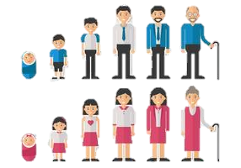
We are learning about our bodies and our relationships with ourselves and others. We are focusing on how these things grow and change over time.
You should already know that: Our bodies have many different parts that have different jobs. Throughout puberty, our bodies go through several different changes. We also go through emotional changes.

Knowing our Bodies
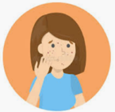  Is this Normal?  As we grow up, our bodies change and develop. This change can be quite unsettling at the time, so it is important that we know what to expect.  - Puberty is the series of changes that our bodies make as we turn from boys and girls into men and women  - Puberty starts between ages 8 and 13 in girls and ages 9 and 15 in boys. At this age, young people will become aware of changes that are taking place to their bodies.  There is lots of information available to us, but it is important to know what is true and what is false.  Some key terms that relate to puberty are:  Acne Body Odour Period  Breasts Penis Vagina Hormones | 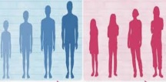  Puberty and Feelings  Puberty starts when hormones are triggered by the brain. Hormones also affect our mood and our feelings. This can make a young person think and feel different. They may want to be more independent and think about adulthood.  -Young people should learn what their different feelings are, e.g. anxiety, anger, disappointment.  -They should take appropriate steps to manage their feelings, e.g. speaking with a trusted adult, breathing techniques, making a pros and cons list, etc.  -Remember that you should always treat other people with kindness and respect, even when you are having a difficult day!

