
Golden Thread: Belonging
Physical Education – Unit 1 – Attack, Defend, Shoot
Autumn 1
Year 1
Working together to be the best that we can be

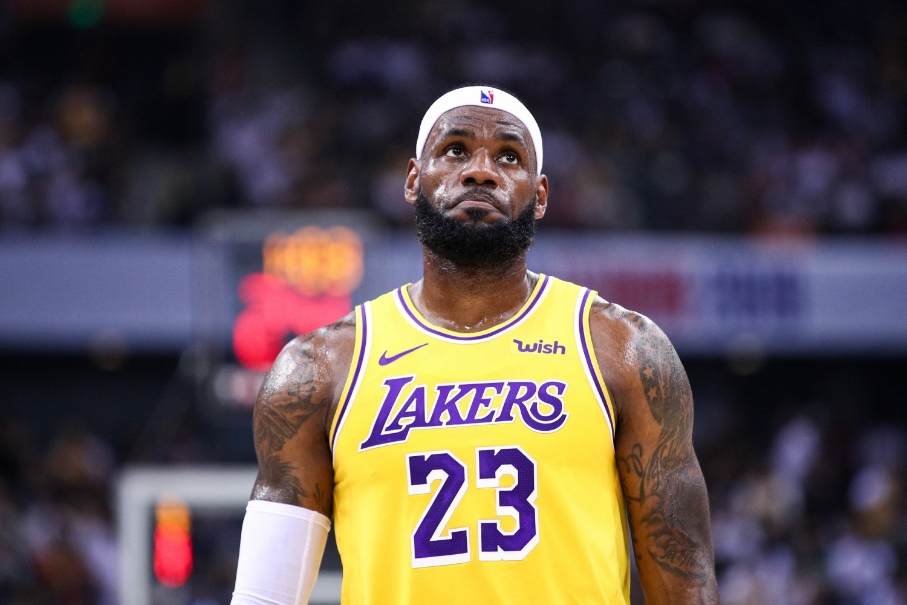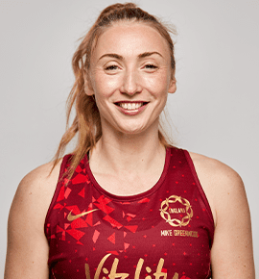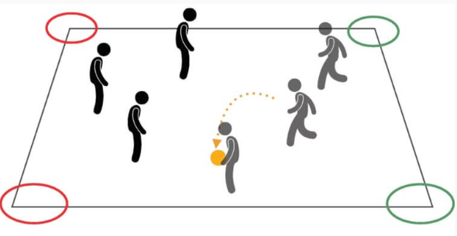
Key Vocabulary:
Attack, catch, compete, defend, overarm, play against, receive, rolling, send, throw, underarm.

LeBron James Jade Clark
Match Play

New Skills:
Underarm throw, overarm throw, rolling, sliding, catching, defending, shooting, working as a team, match play.

