
Golden Thread: Belonging
Physical Education – Unit 1 – Attack, Defend, Shoot
Autumn 1
Year 2
Working together to be the best that we can be
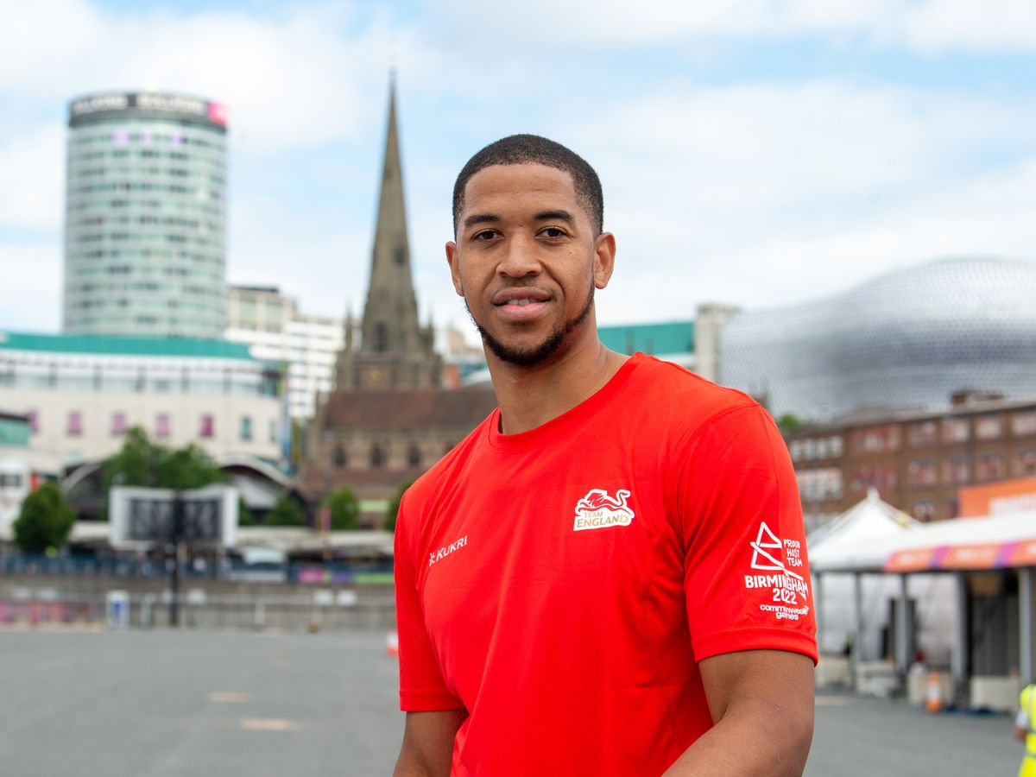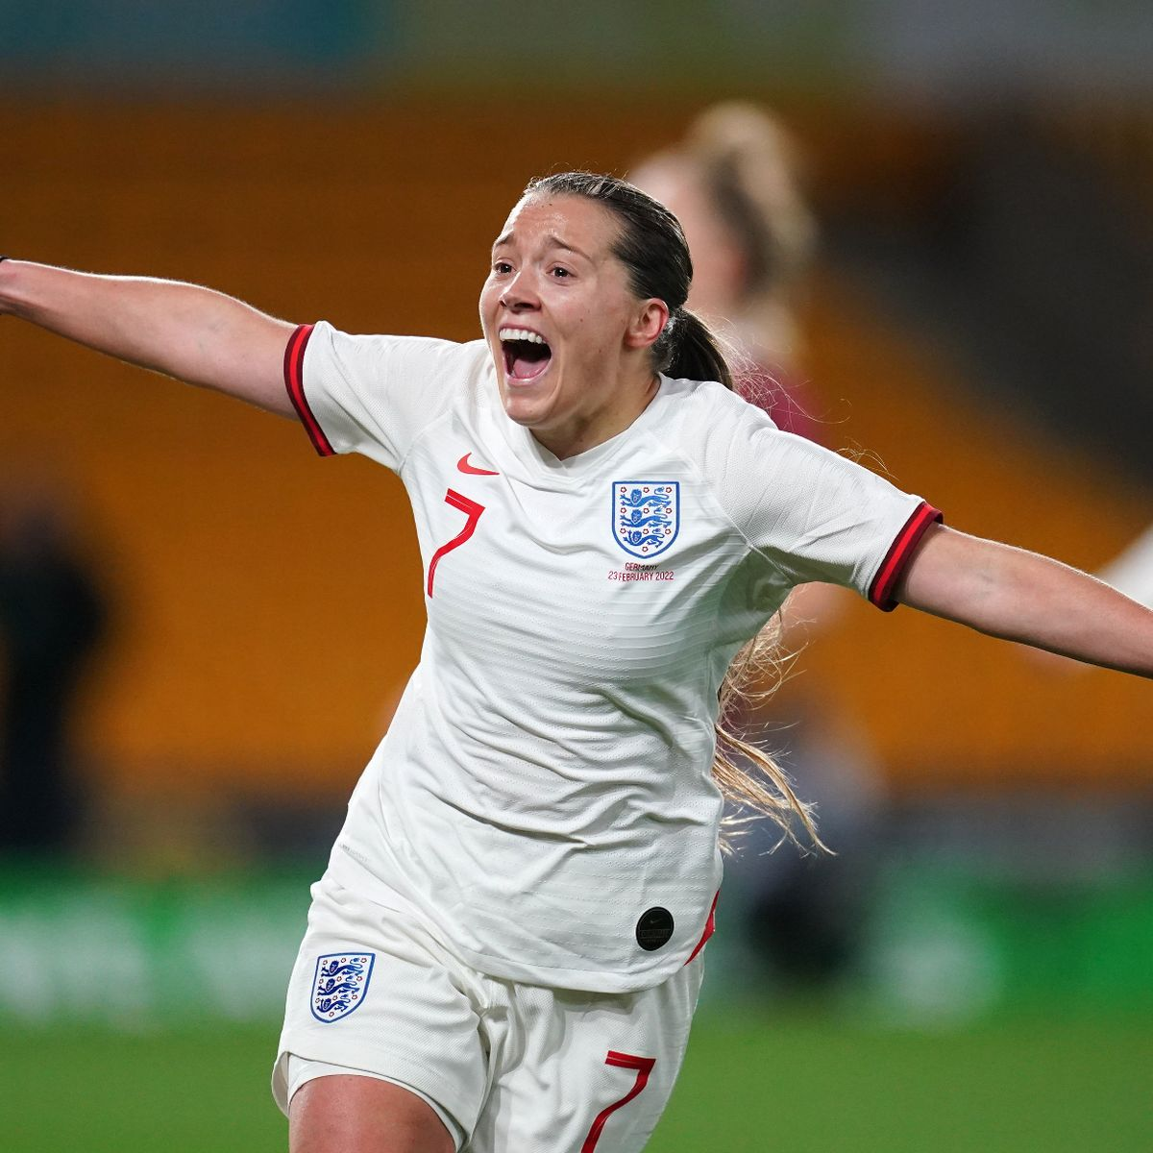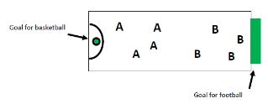
Key Vocabulary:
Aim, attack, compete, controlling, cooperate, receive, control.

Myles Hesson Fran Kirby
Basketball and Football Goals

New Skills:
Kicking the ball, stopping the ball, dribbling with the ball at our feet, dribbling with the ball in our hands, bounce passing, match play.

