
Working together to be the best that we can be
RE – Unit 1 – Christianity: Does God want Christians to look after the world?
Golden Thread: Sustainability

Autumn 1
Year 1

Key Vocabulary
Bible | Christian Holy Book
Old Testament | The part of the Bible which explains God’s relationship with his people before Jesus, whom Christians believe is the Son of God, came to earth
Genesis | First book of the Bible
Christianity | The religion based on the life and teachings of Jesus
God | A loving being who created things

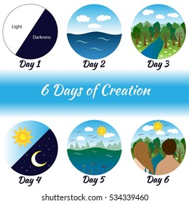
The Creation Story is found in the Bible. Christians believe that God created the world and everything in it in six days, then rested on the seventh day.

Christians’ believe that God wants people to look after the world He has created it for them. This is called being a good steward.
Theme: The Creation Story




Does God want Christians to look after the world?

Our world is precious we need to look after it!

How do people treat the world?

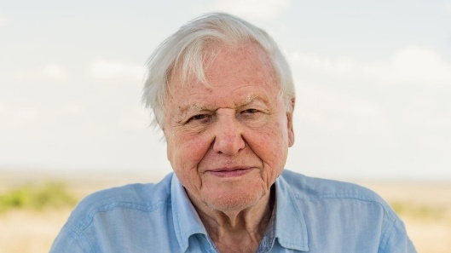


Sir David Attenborough – Naturist
My name is Abbey, it means ‘wisdom’.

