
RE – Unit 1 – Christianity: Is it possible to be kind to everyone all of the time?
Working together to be the best that we can be
Golden Thread: Social Justice

Autumn 1
Year 2

Key Vocabulary
Samaritan | a person from Samaria, a country near where Jesus was teaching.
Levite | a legal expert who would have known that it states in the law that he should help an injured man.
Pharisee | a strictly orthodox Jew who adhered closely to the rules and scriptures.
Parables | stories that Jesus told to illustrate points he was trying to make in a way (or setting) that his listeners would understand.

It is difficult to be kind all the time especially when others are nasty or unkind towards us. Sometimes we have to make a choice to be kind even when it is difficult.
Theme: what did Jesus teach?

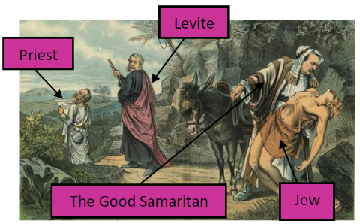
This is a parable where Jesus gives an example of how to be kind to an enemy. Jews despised Samaritans because they were mixed race. In the story, a Jewish man, is attacked by robbers, who leave him for dead on the road. Then, a priest and a Levite went past but did not help him. Finally, a Samaritan saw the man and had compassion for him.


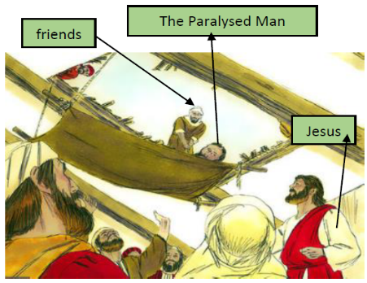
This story is a miracle recorded in one of the Gospels. Jesus was in Capernaum teaching a large crowd, when four determined men, who were bringing their friend to be healed, interrupted him. They made a hole on the roof of the house Jesus was at and lowered him down in front of Jesus. He had compassion on the man and healed him.



Is it possible to be kind to everyone all of the time?

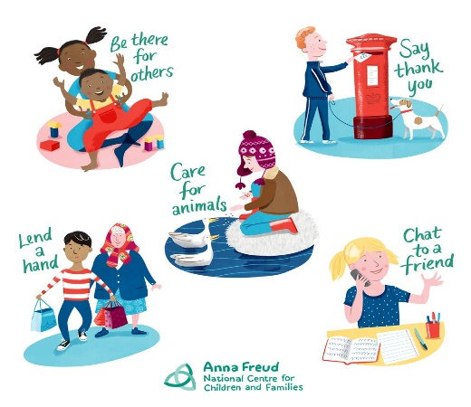


What does kindness look like?

Remember to be kind to be everyone!


My name is Sofia, it means ‘wisdom’.

Mother Theresa – Catholic Nun

