
RE – Unit 1 – Hinduism: Would celebrating Divali at home and in the community bring a feeling of belonging to a Hindu child?
Working together to be the best that we can be
Golden Thread: Belonging

Autumn 1
Year 3

Key Vocabulary
Festival | a time or event of celebrations
Divali | a festival commemorating the Ramayana
Exile | a person who is forced to leave their own country.
Lakshmi | Hindu Goddess of Wealth
Legend | an old story that is widely believed but cannot be proved to be true.
Rama | a king of ancient India.
Sita | The wife of Rama.

Diwali is an important religious festival originating in India. Diwali takes place annually and lasts for five days, marking the start of the Hindu New Year. Diwali is an extremely popular Hindu festival which happens at the start of winter. It celebrates the story of the Ramayana which describes the events leading up to the return of Rama to his kingdom after fourteen years in exile. It is a classic story of good defeating evil.
Theme: Divali

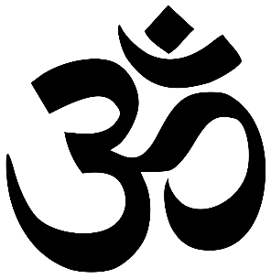
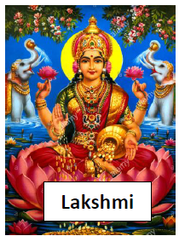
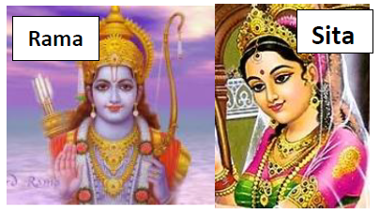


Rama and Sita had defeated an evil demon called Ravana and were returning home. On the night of the return, however, there was no moonlight, so the people of the kingdom lit lots of small lamps to welcome him back. This is why Diwali is called the ‘Festival of Lights’.
Would celebrating Divali at home and in the community bring a feeling of belonging to a Hindu child?
?

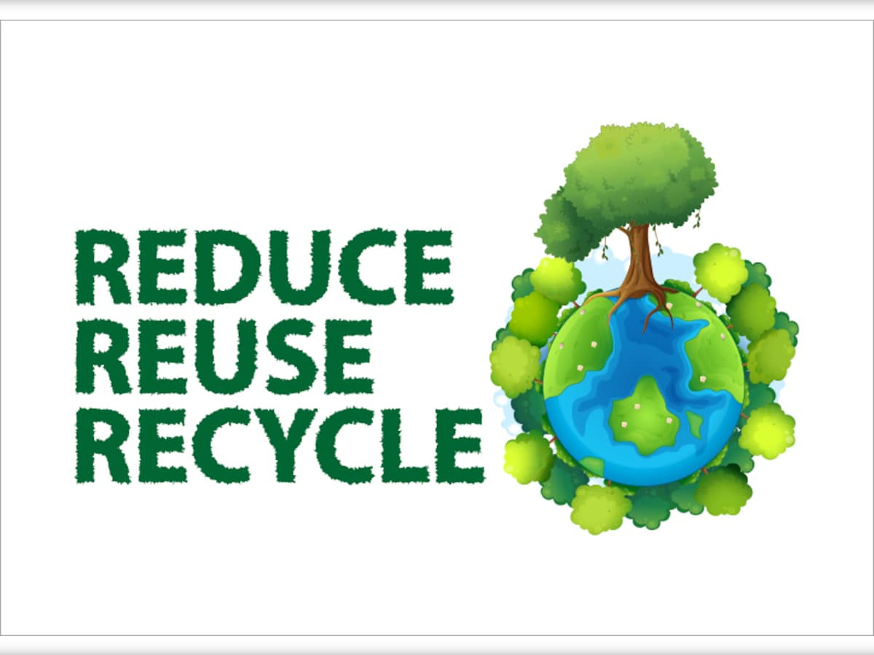
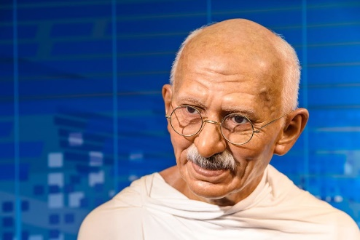
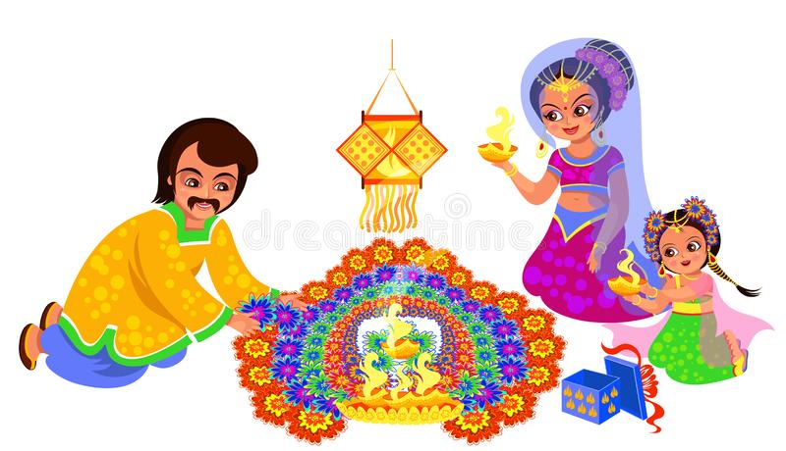
Diwali is not just about lights and legends –– Diwali is a time to have fun with friends and family! People exchange gifts and sweets, enjoy delicious feasts, watch firework displays and wear new clothes. It’s a time to clean and decorate your home, too.

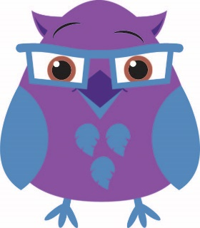
My name is Huey, it means ‘wisdom’.
Mahatma Ghandi – Civil Rights Activist

