
RE – Unit 1 – Judaism: How special is the relationship Jews have with God?
Working together to be the best that we can be
Golden Thread: Belonging

Autumn 1
Year 4

Key Vocabulary
Jew/Jewish | a person who follows the religious teachings of Judaism
Hebrew | the language of Judaism. The Torah is written in Hebrew
Synagogue | a place of worship for Jews
Torah | a sacred text of the Jews
Abraham | known as the Father of Judaism
Covenant | a promise
The Ten Commandments | ten laws given to Moses from God that Jews have to follow
Moses | led the Jews out of slavery from Egypt. God gave him the 10 Commandments

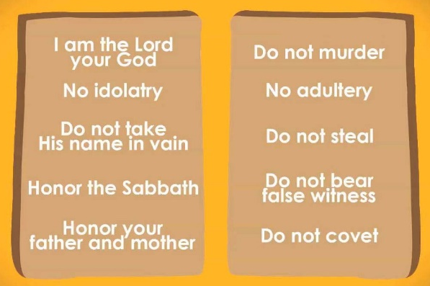
In our lives we all have promises and agreements that we make with others. Some may write these promises down, wear something to show we made a promise or perform an act to remind us our promise. Jews believe that there is one God who created the world. Jews believe that they can have a special personal and individual relationship with God. Jewish history begins with the covenant between God and Abraham around 1812 BC. God promised he would look after Abraham and his descendants.
Theme: Beliefs and Practices



Moses was given the Ten Commandments and God asked the Jewish people to live by these as their promise to him. These are still held in Jewish belief today.
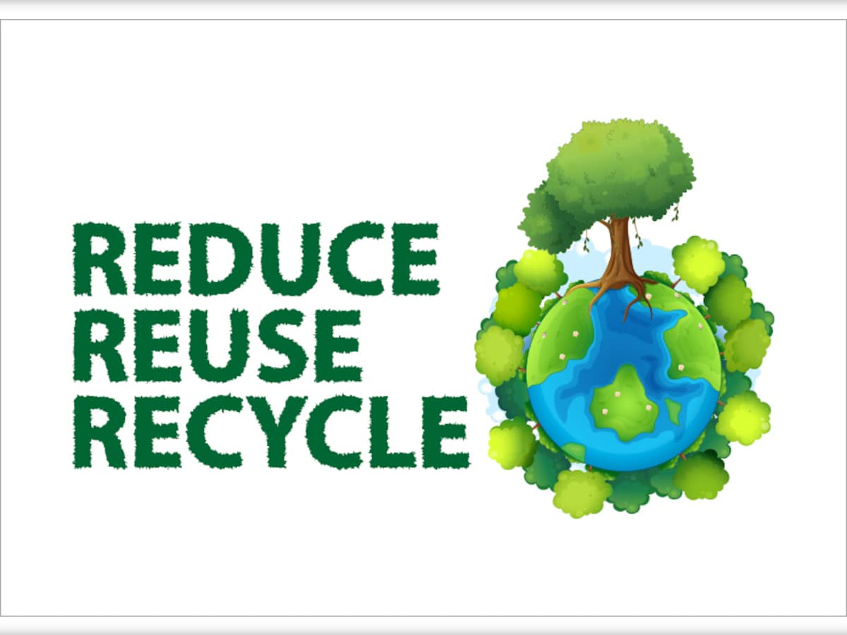


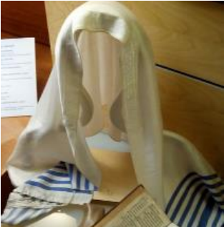


How special is the relationship Jews have with God?

Inside a synagogue
A prayer shawl (tallit) with ten knots on each end as a reminder of the Ten Commandments.
The Commandments are written in the Torah which is read to Jewish people in the synagogue.
My name is Egbert, it means ‘wisdom’.

