
RE – Unit 1 – Sikhism: How far would a Sikh go for his/her religion?
Working together to be the best that we can be
Golden Thread: Belonging

Autumn 1
Year 5

Key Vocabulary
Gurdwara | Sikh place of worship
Guru | teacher: used in Sikhism to refer to the ten human Gurus and Guru Granth Sahib.
Guru Granth Sahib | Sikh Holy Book that gives guidance on how Sikhs should lead their lives. It is considered as the living Guru
Khalsa | The Sikh community
The Five Ks | the symbols of Sikhism worn by Sikhs.
Langar | community kitchen in a Gurdwara where a free meal is served to all the visitors, regardless of their religion, gender, economic status or ethnicity.
Guru Nanak | the first Guru and founder of the Sikh faith (1469-1539)

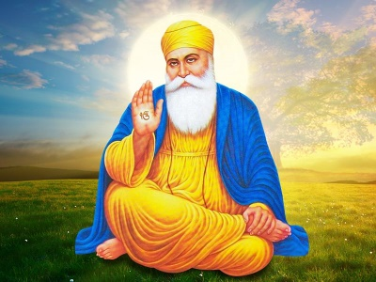
Guru Nanak was the first Sikh Guru. He came from a small town in India 500 years ago. He taught his followers that everyone was equal and told them how to love and follow God. People called him ‘Guru’ because he taught them about God. He travelled around India, spreading God’s message that everyone is equal.
Theme: Beliefs into Action

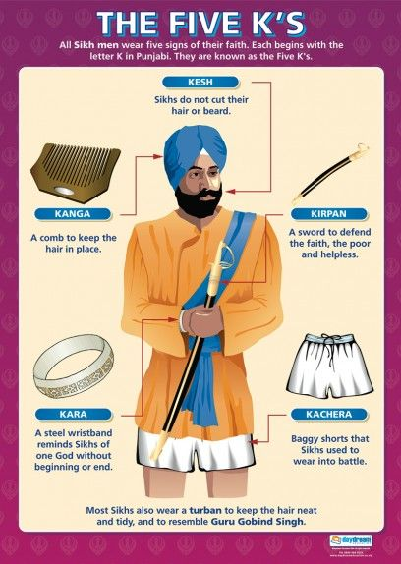

Sikhs show their commitment to their religion in various ways. Their commitment and participation to these aspects of their religion also generates a sense of belonging.
The Five Ks: These are physical signs to yourself, others and the world that you are a member of the Khalsa.



How far would a Sikh go for his/her religion?

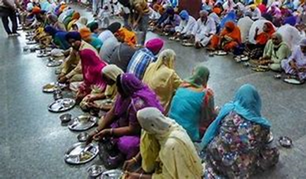

The Langar: This was started by Guru Nanak and means everyone, regardless of their religion or wealth, sits and eats freely provided food and drink. The people sit together as equals. The preparation and serving of food as well as cleaning is voluntary and a key part of every Gurdwara.
My name is Auberon, it means ‘wisdom’.

