
RE – Unit 1 – Islam: What is the best way to for a Muslim to show commitment to God?
Working together to be the best that we can be
Golden Thread: Belonging

Autumn 1
Year 6
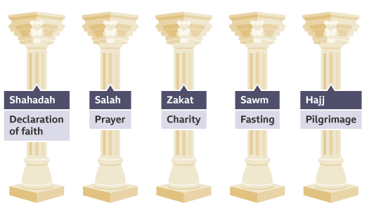

Key Vocabulary
commitment | being dedicated to a cause or an activity
Muslim | a follower of the religion of Islam
Allah | the Arabic name Muslims use for God
Ramadan | the month of fasting and prayer
Muhammad | the final prophet of Islam
Qur’an | holy book. The word of Allah in Arabic
Fasting | abstain from food and drink as a religious observance

Within Islam, there are compulsory duties that Muslims must try to carry out. All Muslims follow the Five Pillars of Islam. The Five Pillars of Islam are five duties that Muslims of all branches of Islam must follow.

Theme: Beliefs and Practices


Shahadah some see this as the most important belief within Islam as it sums up what a Muslim should believe in and it supports the other four pillars.


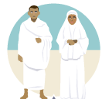
Salah this is the belief that Muslims should pray five times each day. Prayer is important as it allows Muslims to communicate with Allah.
Things Muslims must do during the Hajj
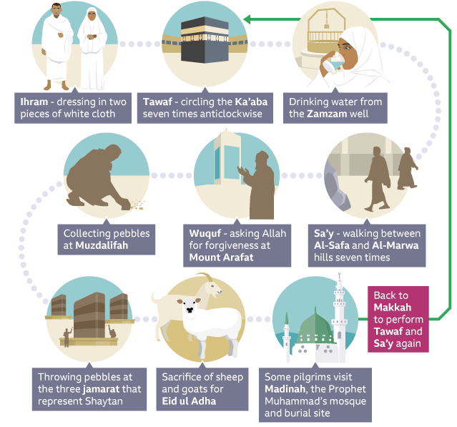
What is the best way to for a Muslim to show commitment to God?


Zakah giving money to the poor. Muslims believe that it is their duty to ensure Allah’s wealth has been distributed equally as everyone is the.


Sawm this happens during the ninth month of the lunar calendar, during Ramadan. Ramadan is special because it is believed to be the month in which the Prophet Muhammad began to receive revelations of the Qur’an.

Hajj the pilgrimage to Makkah. All Muslims are expected to go on Hajj once in their lifetime if they are physically, financially and mentally able to.
My name is Gudrun, it means ‘wisdom’.

