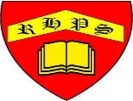
Golden Thread: Material Culture
Working together to be the best that we can be
Art – Drawing and Sketching – 2D Drawing to 3D Making
Autumn 1
Year 6
Is the design unique? Is it eye- catching?

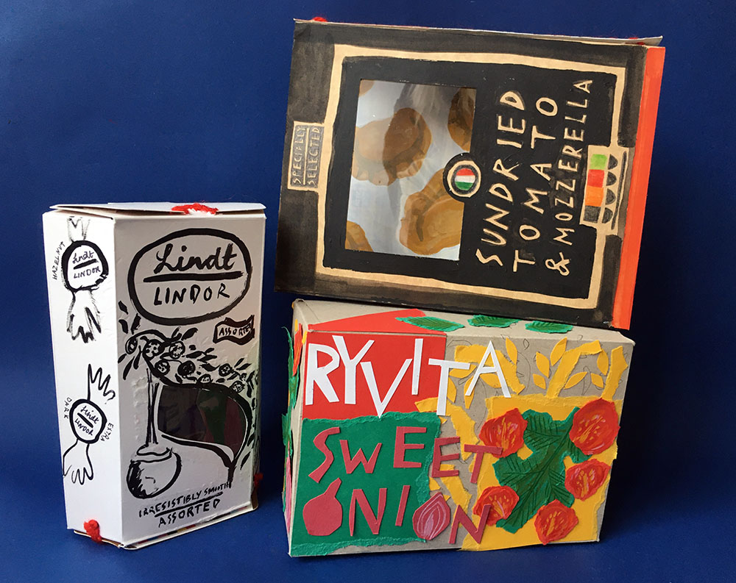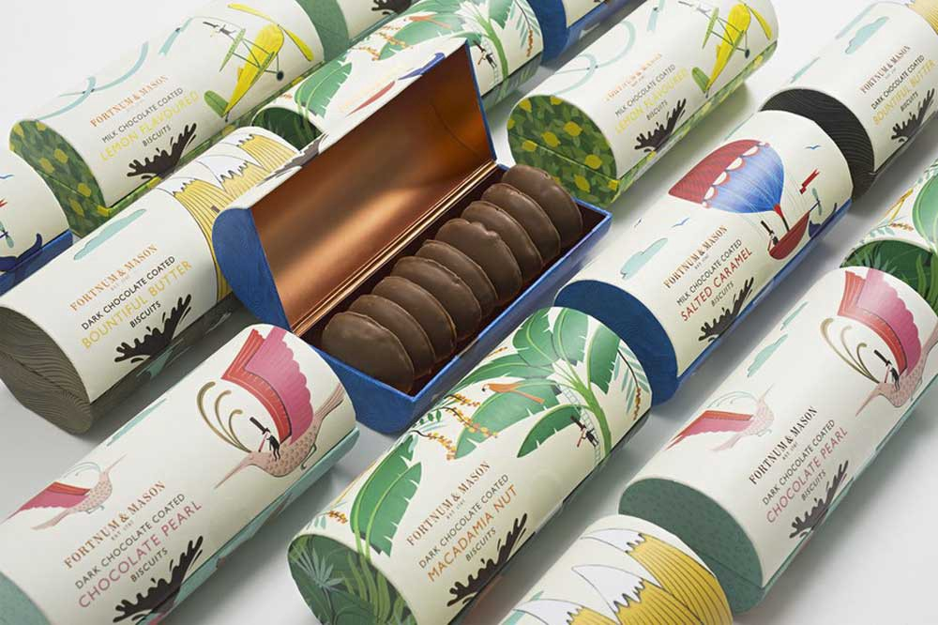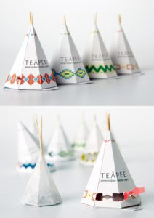

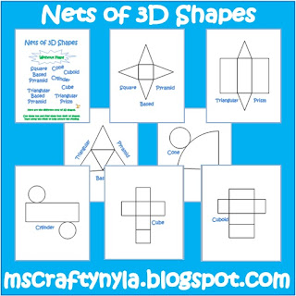

Who are your customers?
What makes the design appealing?

Which colours will you use?

Can you choose effective lettering?
2D drawing
3D drawing
Net
Typography
Graphic Design
Packaging
Visual representation
Colours
Shapes
Fonts

Claire Harrup is an illustrator and printmaker living and working in Essex, UK.
​She has worked for: Waitrose, The National Trust and Gardens Illustrated
