
Aut/Spring/Sum
Science – Seasonal Change
Golden Thread: Sustainability
Year 1
Working together to be the best that we can be
Spring
Days start to get longer. Snow begins to melt as the weather gets warmer. Plants begin to grow and flowers to bloom. Animals awaken from hibernation. Babies are often born in spring. In some parts of the world, spring brings rain that falls for hours on end; this starts the growth of different plant life.
Winter
Winter is the coldest season. Snow falls in the Winter. Every snowflake has six sides. Trees and plants stop growing in the Winter. Nights are longer in the Winter. Some animals hibernate in the Winter.
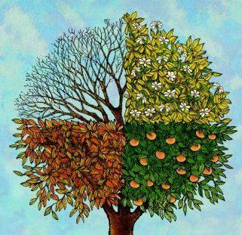

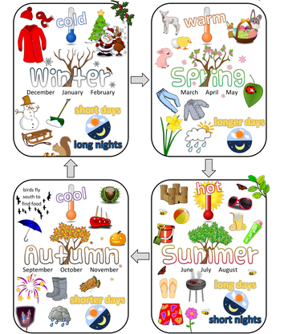

Summer
Weather in the summer grows warmer, it is the hottest season. Plants grow well, fruit on trees is produced and flowers come into bloom. This hot, dry time of year can lead to droughts, where water is in short supply in some places around the world.
Autumn
Autumn is the season of the year that transitions summer into winter. Along with the tree leaves changing colour to oranges, browns and reds, the temperature grows colder, plants stop making food, animals prepare for the long months ahead, and the daylight starts growing shorter. Deciduous trees will eventually lose their leaves.

