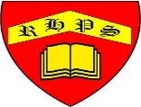
Science – Unit 1 – Biology: How do we look after our bodies? (Diet and Nutrition)
Golden Thread: Sustainability
Autumn 1
Year 3
Working together to be the best that we can be
Key Vocabulary
contracts | When a muscle shortens sand tightens
forage | to look for wild food
harvest | to collect food from plants
muscle | soft tissue in the body that contracts and relaxes to cause movement of the skeleton
nutrition | they get nutrition from what they eat
relax | When a muscle lengthens
skeleton | a structure of bones that supports and protects a human and animal’s body and vital organs
tissue | a type of natural material plant and animals are made of
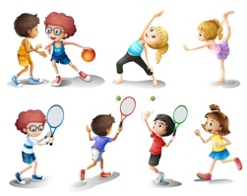
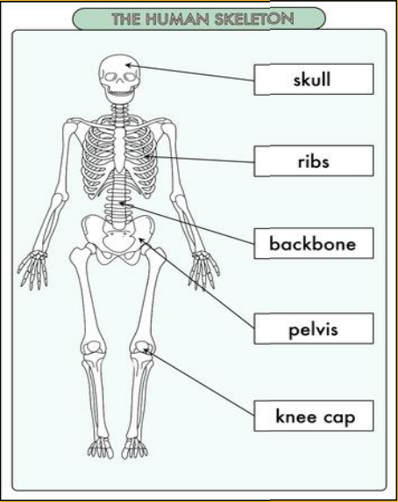
Humans need:
- A balanced diet of the right amount of different types of food and drink
- To exercise regularly
- To be hygienic
- To have enough rest
All animals and humans need air (oxygen), water, food, and shelter to survive.

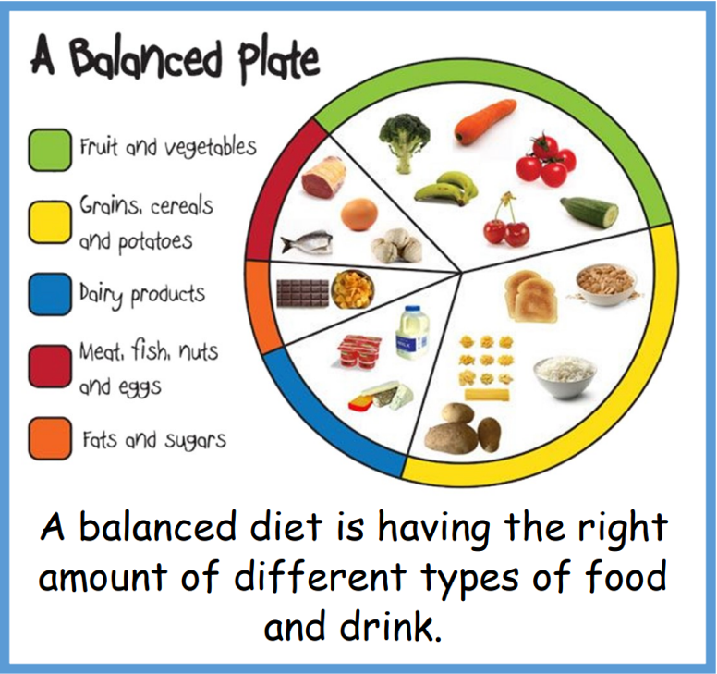

.


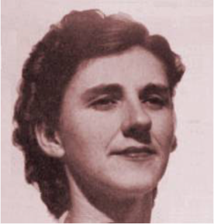
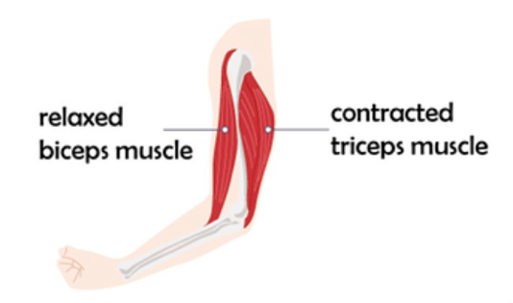
Did you know?
Adelle Davis was the most famous nutritionist in the 1900s

