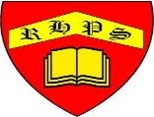
Science – Unit 1 – Biology: What happens to our food when we eat?
Golden Thread: Belonging
Autumn 1
Year 4
Working together to be the best that we can be
Key Vocabulary
Digest | Break down food so it can be used by the body.
Oesophagus | A muscular tube which moves food from the mouth to the stomach.
Stomach | An organ in the digestive system where food is broken down with stomach acid and by being churned around.
Small intestine | Part of the intestine where nutrients are absorbed into the body.
Large intestine | Part of the intestine where water is absorbed from remaining waste food. Faeces are formed in the large intestine.
Rectum | Part of the digestive system where faeces are stored before leaving the body through the anus.
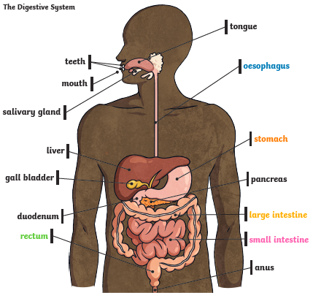

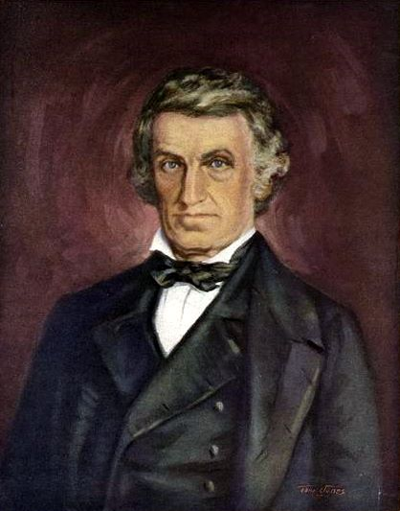

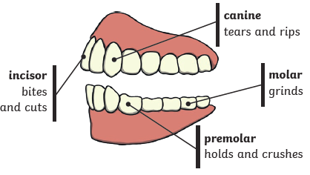
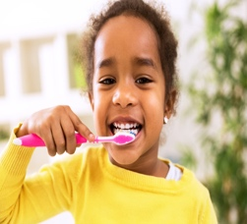
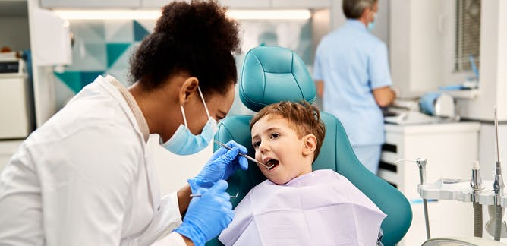
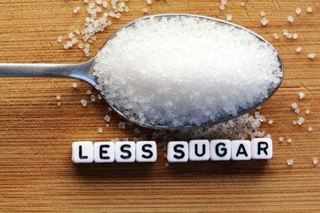
Human teeth and their functions.
Did you know?
William Beaumont was able to observe digestion by looking directly into a hole in a patient’s stomach over a 10-year period.

How to look after
your teeth.

