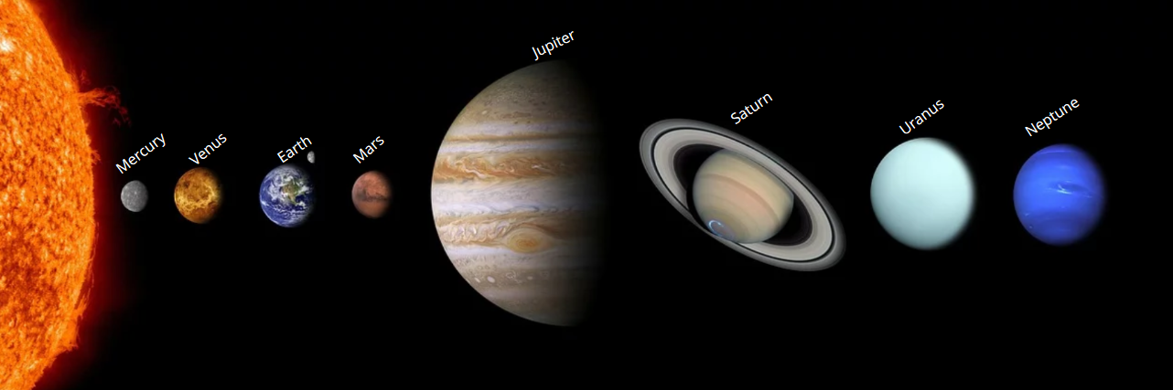
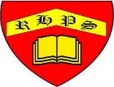
Golden Thread: Sustainability
Science – Unit 1 – Physics: How does the Earth spin?
Autumn 1
Year 5
Working together to be the best that we can be
Key Vocabulary
Sun | A huge star that the Earth and other planets in the solar system orbit around.
star | A giant ball of gas held together by its own gravity.
moon | A natural satellite which orbits around the Earth or other planets.
planet | A large object, round or nearly round, which orbits around a star.
sphere | A round 3D shape in the shape of a ball.
spherical bodies | Astronomical objects shaped like spheres.
orbit | To move in a regular, repeated curved path around another object.
rotate | To spin.
axis | An imaginary line that a body rotates around.
geocentric model | A belief other people used to have that other planets and the Sun orbited around Earth.
heliocentric model | The structure of the Solar System where the planets orbit around the Sun.

Mercury, Venus, Earth and Mars are rocky planets. They are mostly made up of metal and rock. Jupiter, Saturn, Uranus and Neptune are mostly made up of gas (helium and hydrogen) although they do have cores made up of metal and rock.

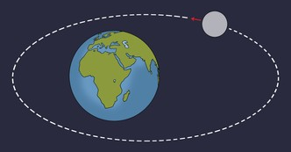

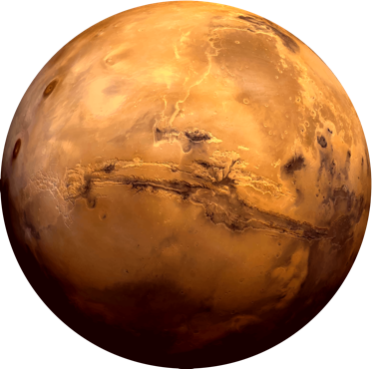

NASA is hoping to land the first humans on Mars by 2030s.

The Moon orbits the Earth anticlockwise in an oval shaped path and takes approximately 28 days. The Moon spins once on its axis every time it orbits Earth. This means that we only see one side of the Moon. The Moon has different phases depending on where it is in its orbit. The Moon’s gravity causes high and low tides.

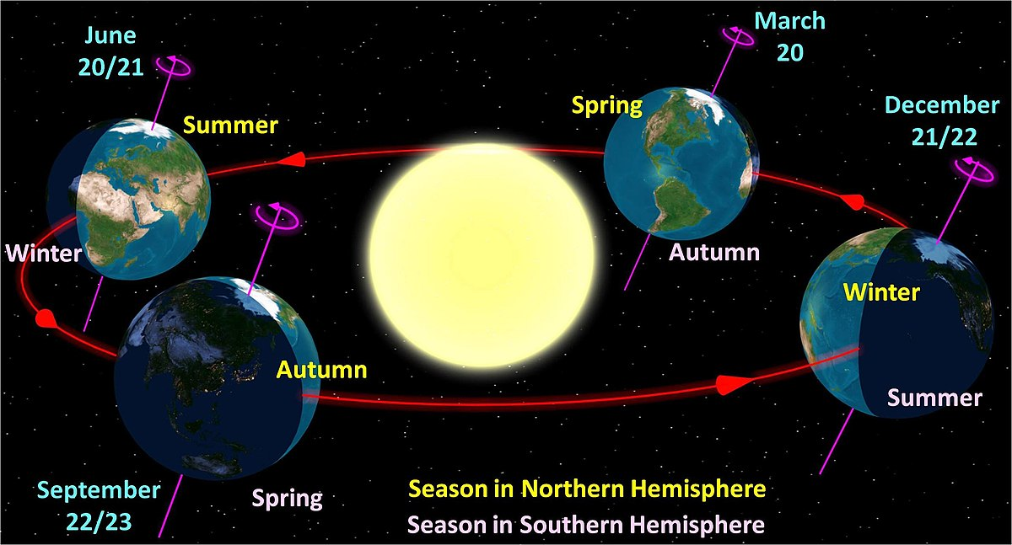

The Earth - Year Length and Seasons

The Earth takes 365 and a quarter days to orbit the Sun. Due to the extra quarter day it takes to orbit the Sun, every four years on Earth is a leap year! The Earth is held in its orbit round the Sun by the Sun’s gravitational pull. It is the Earth’s tilt that causes the seasons.

A moon is a celestial body that.
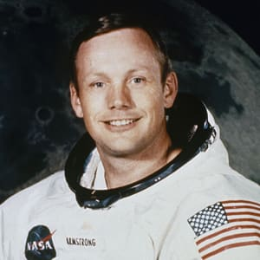

Did you know?
Neil Armstrong was the
first man to walk on the moon.

