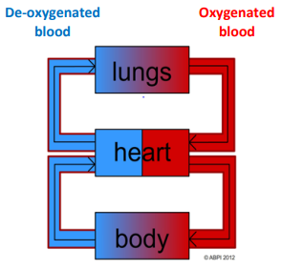
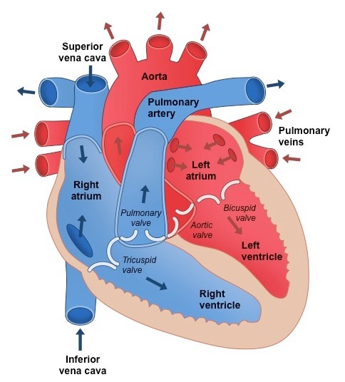
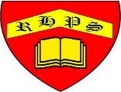
Science – Unit 1 – Biology: Why do we need to look after our Heart?
Circulatory System
Golden Thread: Sustainability
Autumn 1
Year 6
Working together to be the best that we can be
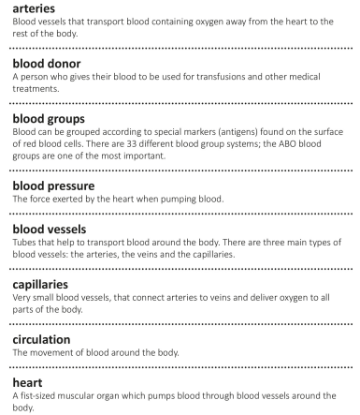
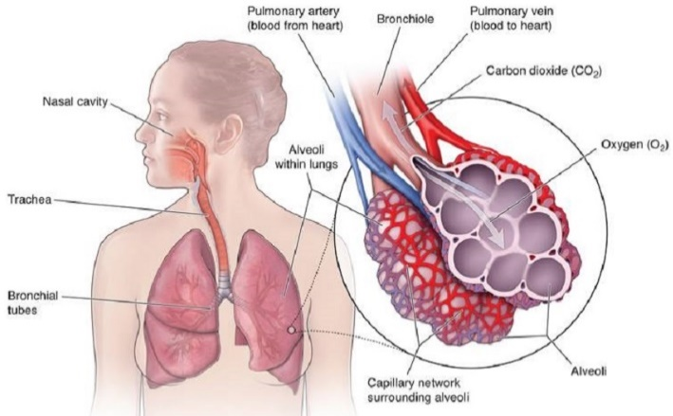
.

The circulatory system is made up of your blood vessels and heart. Blood moves food, water, oxygen and waste products around the body. The heart pumps blood around the body. There are 3 types of blood vessels that carry blood;
- Arteries- carry blood away from the heart to the body
- Veins- Carry blood away from the body back to the heart
- Capillaries- allow substances to move in and out of the blood.

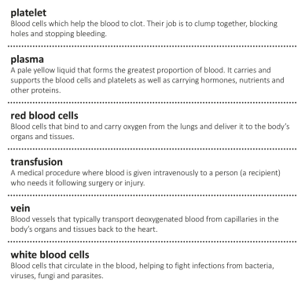
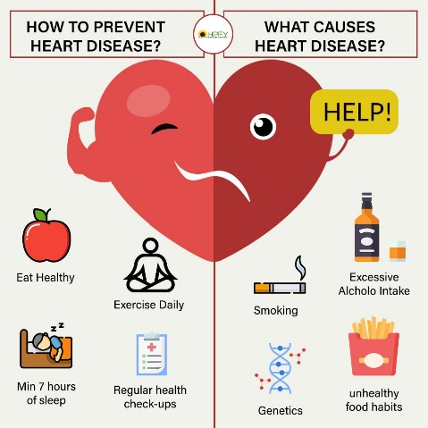
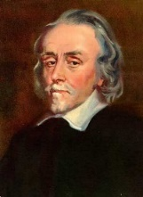
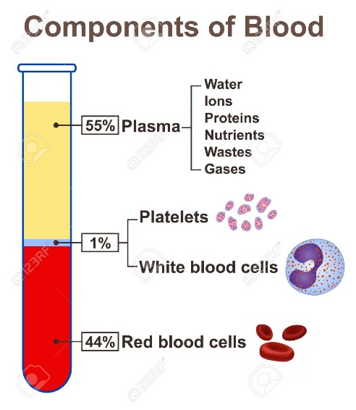
Did You Know? Your heart rate is how many times your heart beats in one minute. The average resting heart rate for a human is around 80 beats per minute!
William Harvey, (born April 1, 1578, Folkestone, Kent, England—died June 3, 1657, London), was an English physician who was the first to recognize the full circulation of the blood in the human body and to provide experiments and arguments to support this idea. He showed that arteries and veins form a complete circuit. The circuit starts at the heart and leads back to the heart. The heart's regular contractions drive the flow of blood around the whole body.

