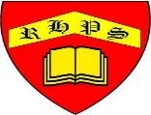
Science – Unit 1 – Biology: What came first, the chicken or the egg?
Golden Thread: Sustainability
Autumn 1
Year 2
Working together to be the best that we can be
Key Vocabulary
adult | A fully grown animal or plant
develop | To grow bigger and become stronger
female | Girl
growth | The process of getting bigger
life cycle | The changes living things go through to become an adult
male | Boy
offspring | The child of an animal
young | Offspring that has not reached adulthood
live young | Offspring that has not hatched from an egg

All young animals change as they go through the different stages of their life cycle and grow into adults.
Some adult animals give birth to live young.
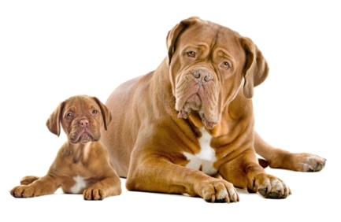

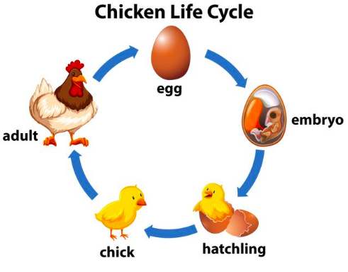
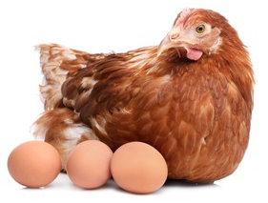
Some animals lay eggs which the
young hatch from.

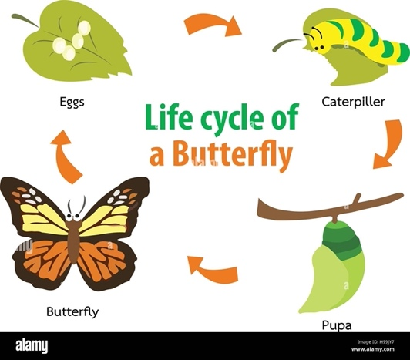
Both of these types of young then develop into adults.
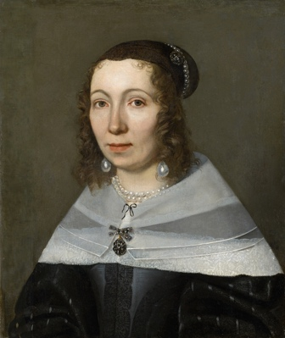

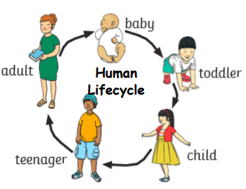
Did you know?
Maria Sibylla Merian discovered the caterpillar/butterfly life cycle.

