
Golden Thread: Belonging
Physical Education – Unit 1 – Football
Autumn 1
Year 4
Working together to be the best that we can be
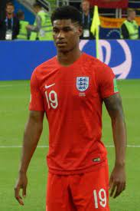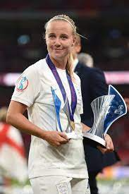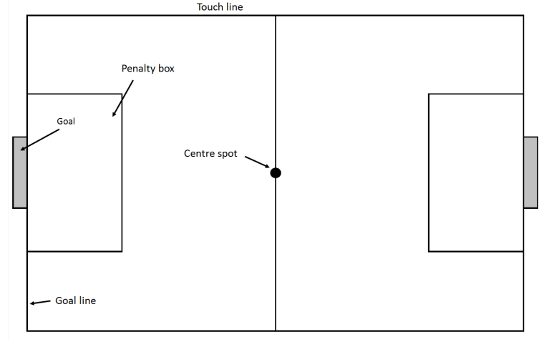

Marcus Rashford MBE, Beth Mead, Harry Kane, Chloe Kelly
Football Pitch

Key Vocabulary:
Control, use space, defend, defensive, attack, dribble, pass, tactics, direction, tackle.

New Skills:
Passing on the move, tackling, marking, long distance passing, dribbling and match play.

