
Golden Thread: Belonging
Physical Education – Unit 1 – Handball
Autumn 1
Year 3
Working together to be the best that we can be
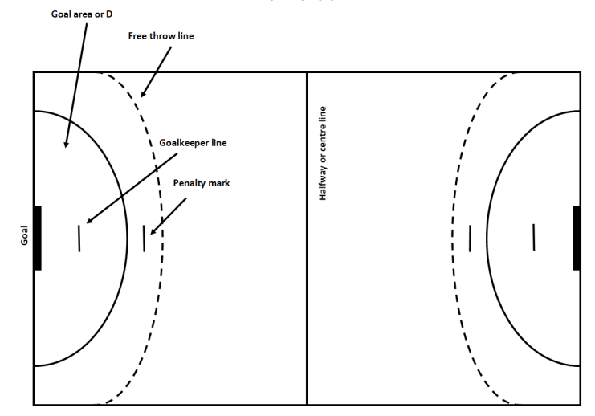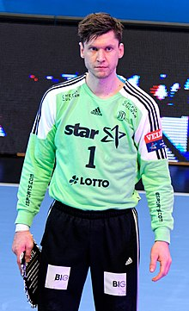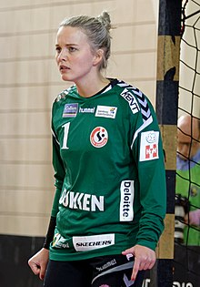

Key Vocabulary:
Shoot, defend, attack, block, run, control, catch, pass, teamwork, score, handball, intercepting.

Niklas Landin Jacobsen and Sandra Toft
Handball Pitch

New Skills:
Catching, underarm throw, overarm throw, bounce pass, three-step rule, intercepting, attacking, match play.

